**5G NR Band n78 8T8R Radio Unit Beamer Sub System**

**Downlink Beamer Sub System**

|  |  |  |  |  |
| --- | --- | --- | --- | --- |
| Revision Number | Date | Description of Change | Author | Approved By |
| 1.0 | 18-11-2022 | Initial version of Design document | Capgemini |  |
| 1.1 | 24-11-2022 | DL Beamer Weights Configuration | Capgemini |  |
|  |  |  |  |  |
|  |  |  |  |  |
|  |  |  |  |  |
|  |  |  |  |  |
|  |  |  |  |  |
|  |  |  |  |  |
|  |  |  |  |  |
|  |  |  |  |  |

**Contents**

1. Introduction
   1. 5G & 4G Beam Structure
2. Requirements
3. Architecture
4. Beamer Sub System
5. DL Beamer
   1. Beamforming Algorithm
   2. Data Stream Processing Unit (DSPU) architecture
   3. DL Beamer MAC Core Architecture
   4. List of Files
   5. Configuration Data
   6. Configuration Analysis
6. Synthesis
   1. Schematic Block Diagram
   2. Synthesis Reports
7. Simulation Results
8. Modifications
9. Beamer IP I/O Interface
10. Beamer Weights Configuration

**1.** **INTRODUCTION**

Beamforming is a procedure, which steers majority of signals generated from an array of transmitting antennas to an intended angular direction towards the user equipment. Specifically, beamforming sends the same symbol over each transmit antenna with a weighted scale factor. 5G NR and ORAN specifications define beamforming procedures that transforms data spatial streams to antenna port streams for DL signal or from antenna port streams to spatial streams for UL signal. n78 coverage is naturally limited in range and building penetration by the propagation characteristics of the higher frequencies used, however the effect has in some ways been mitigated by advanced processing techniques such as massive MIMO, beam forming, and beam-tracking.

Beamer Subsystem comprising DL Beamer, UL Beamer, PRACH Beamer and SRS Extractor. The subsystem performs interfacing between other Low-PHY subsystems and the ORAN Radio Interface Subsystem and the TX/RX beamforming functionality (except for SRS Extractor).

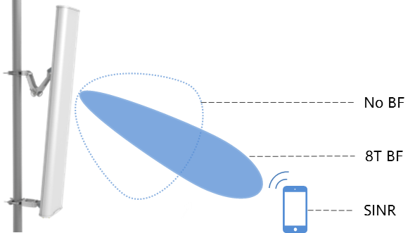

* 1. 5G & 4G Beam Structure

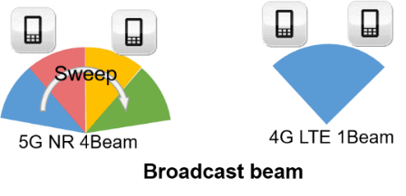

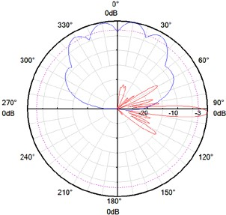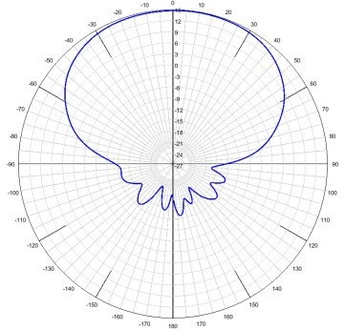

**5G**  **4G**

**2. REQUIREMENTS**

|  |  |
| --- | --- |
| Parameter | Requirements |
| Frequency bands | N78: 3300-3700 MHz |
| Radio configuration | 8T8R TDD |
| Beamforming | Predefined BF & weight based dynamic BF |
| Numerology | 15 kHz, 30 kHz |
| Number of carriers | 8 DL / 8 UL |
| OBW | 200 MHz |
| IBW | 400 MHz |
| Number of Antenna ports | 8 |

**3. ARCHITECTURE** 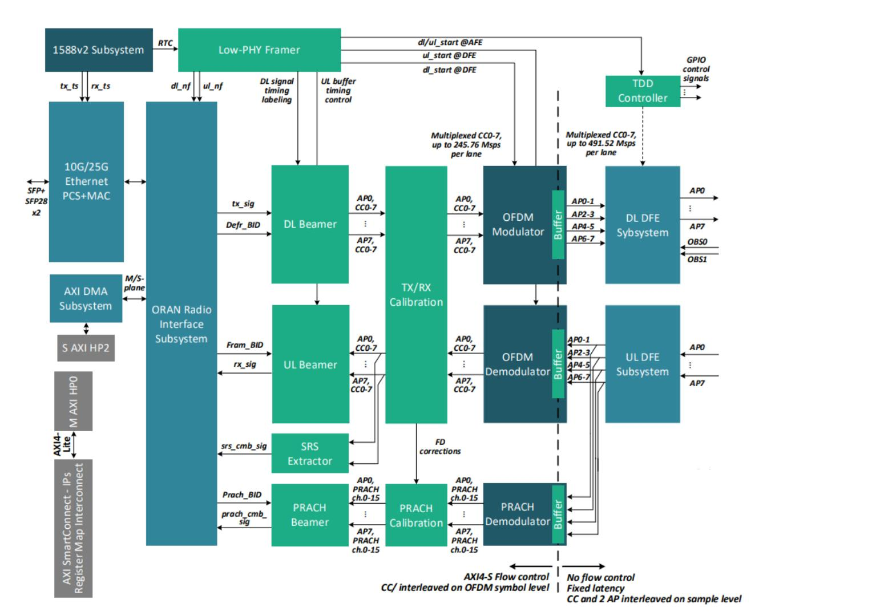

**Block Diagram of ORAN Radio Unit**

1. ORAN Radio Interface Subsystem provides functionality of the RU-side ORAN protocol. The subsystem is connected to the 10G/25G Ethernet and the Low-PHY Beamer. In the DL direction, the ORAN Radio Interface Subsystem receives of the O-RAN CUSM-plane packets from the Ethernet interface, does parsing and preparation of the output AXI4-S streams of data (QAM symbols to be mapped in the FD), beamforming data and other C plane-related data to be used by the Low-PHY blocks. In the UL direction, the subsystem receives input data stream from Low-PHY and performs O-RAN packets building and their transmission to the Ethernet interface (including transmission timing control).
2. The RTC indicated by the Xilinx 1588v2 Timer is then used by the Low-PHY Framer block. According to the SW-configured delays, this block generates several pulse events (strobes) with a defined delays and periodicity relative to the RTC. Two pulses (dl_nf and ul_nf) used for the timing control of the ORAN Radio Interface Subsystem (such as definition of the Ethernet TX/RX window positions).
3. In DL one pulse is used by DL Beamer to perform a proper labeling of the signal flow taken from the ORAN RIS. The label is a pair of the OFDM symbol number within a 10 ms radio frame and the carrier index the symbol belongs to. The label is then transmitted synchronously to the data flow as an AXI4-S tuser bus. The label signal has a sample-level accuracy, i.e. switching of the symbol index (and the carrier index) is performed after the last sample of the previous symbol and Confidential 10 before the first sample of the next symbol. This label is used for controlling further computational blocks of Low PHY. The label is synchronously passed through all CDCs as illustrated above. After the processing steps controlled by the tuser label, the signal (with the label) is put into the timing synchronization buffer (FIFO) inside the OFDM Modulator block.
4. In UL a symmetrical concept is used with replacement of the labeling logic and sync FIFO elements. Assuming the RX DFE has the fixed known latency LUL and full throughput, the signal received by the OFDM/PRACH Demodulator is labeled such as the first sample of the first OFDM symbol of the 10 ms radio frame appears synchronously to the pulse delayed from the accrual radio frame start by LUL. All further processing steps are controlled by the tuser OFDM symbol index / carrier index label and finally the signal (with the label) is put into the RX sync FIFO inside the UL/PRACH Beamer and SRS Extractor blocks.

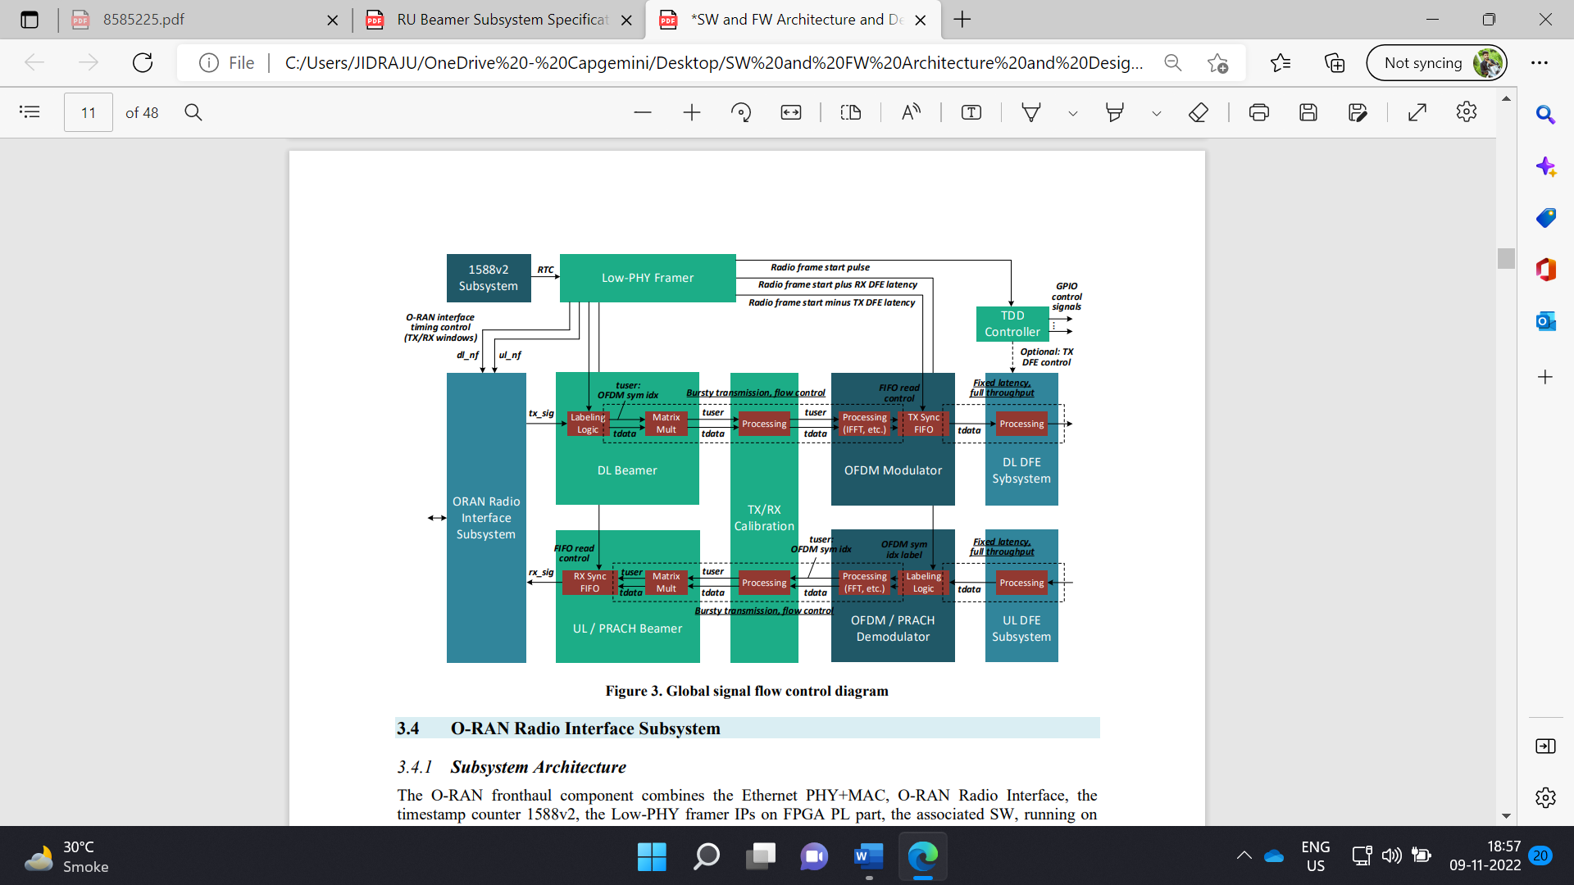

**Global signal flow control diagram**

**4. BEAMER SUB SYSTEM**

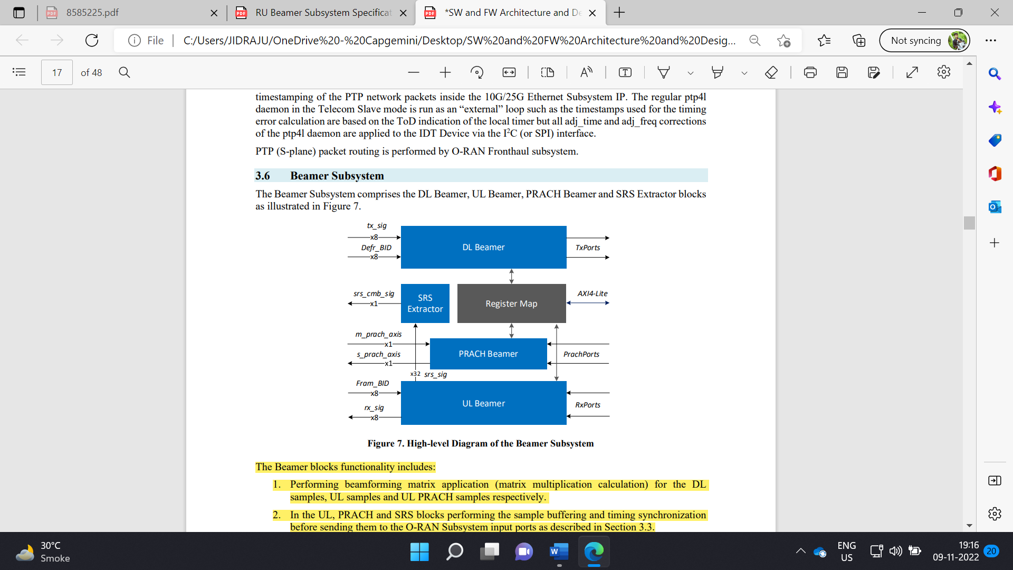

**High-level Diagram of the Beamer Subsystem**

Beamforming is a type of radio frequency management in which a wireless signal is directed toward a specific receiving device and also beamer uses multiple antennas to send & direct the same signal toward a single receiving device (UE). This results in an improved signal at the user equipment (UE) & also less interference between the signals of individual UE.

The Beamer blocks functionality includes:

1. Performing beamforming matrix application (matrix multiplication calculation) for the DL samples, UL samples and UL PRACH samples respectively.
2. In the UL, PRACH and SRS blocks performing the sample buffering and timing synchronization before sending them to the O-RAN Subsystem input ports.
3. In the DL block performing proper sample and OFDM symbol labelling.
4. In SRS Extractor performing SRS subcarriers extraction and routing towards the O-RAN subsystem input.
5. For all blocks: providing a logical interface between the O-RAN Interface Subsystem and the other blocks of the Low PHY design including the beam cache and beam index control, PRACH and SRS location control, etc. All blocks are controlled by the Linux driver via the AXI4-Lite register spaces.
6. The matrix multipliers perform an 8x8 matrix multiplication to transform 8 O-RAN streams (extended antenna-carriers) to 8 antenna signals or vice versa. The matrix multipliers support the OBW of 200 MHz and 1-8 component carriers within OBW.
7. Processing of samples belonging to different carriers is time-divided in the OFDM symbol-by-symbol manner and performed by the same physical multiplier hardware. The order of OFDM symbols is the carrier index first, the time-domain index of an OFDM symbol second.
8. For combination of different numerologies, the order of OFDM symbols corresponds to the order of symbols in the O-RAN Interface Subsystem (TBD) w/o additional buffering and reordering.
9. The output data interface of the DL Beamer (and the input data interfaces of the UL Beamer, PRACH Beamer and SRS Extractor) blocks comprises 8 parallel AXI4-Stream interfaces associated with 8 TX/RX antennas.

**5. DL BEAMER**

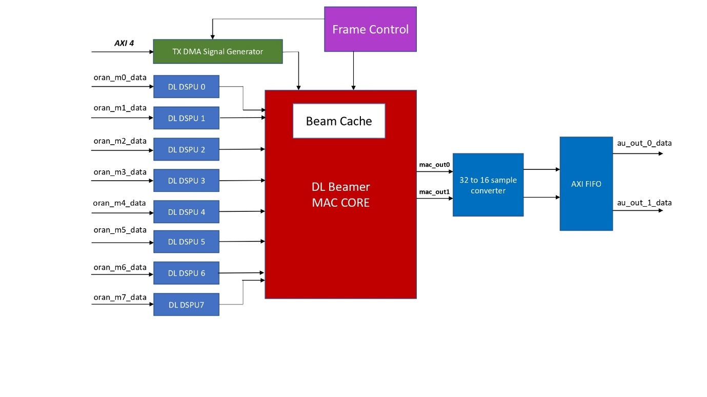

**DL Beamer Top Block Diagram**

Downlink beamer is used for beamforming spatial streams from ORAN IP to antenna port streams with converting output data to the proper format suitable for transmitting to OFDM modulator. DSPU provides input interface of DL Beamer that converts ORAN IP De framer output data to the suitable format for DL Beamer MAC Core. ORAN data processing for one OFDM symbol includes IQ-samples pre-processing, full buffering for data reordering and jitter removal with zero samples insertion for non-scheduled PRBs, clock domain crossing between ORAN and PHY reference clocks. Beamer MAC Core is responsible for 8x8 matrix multiplication to transform 8 spatial streams (extended antenna-carriers) to 8 antenna signals. As the block is a part of the 122.88 x 3 MHz clock domain, the multiplier includes 8x8 scalar complex multipliers. Then products of complex multiplication are summed by adder tree that are also designed via DSP48E2 block.

DL Beamer subsystem includes following modules with corresponded functionality:

* Frame Control – timing and rate control logic according to configured frame parameters and OFDM readiness
* DL DSPU – input interfaces for ORAN spatial streams that are responsible for buffering reordering and data format converting
* TX DMA Signal Generator – input interfaces of test signal stored in PS DDR and used for debug purposes
* DL Beamer MAC Core – core unit of signal beamforming
* Sample converter – MAC Output converter to the target Aurora AXIS format
* AXIS FIFO – output FIFO module to provide AXI4-Stream interface. FIFO depth are selected correspondently to the latency of DL Beam MAC Core.

**5.1. Beamforming Algorithm**

5G NR and ORAN specifications define beamforming procedures that transforms data spatial streams to antenna port streams for DL signal or from antenna port streams to spatial streams for UL signal.

DL beamforming of M spatial streams (SS) to N antenna ports (AP) can be defined as multiplication of a complex subcarrier sample of each SS to a complex beam weight vector for each AP stream. Resulting antenna port signal is the sum of the products.

$$Z_{n}=\sum_{m=0}^{M-1}{W_{nm}D_{m}, n<N}$$

Matrix representation of the DL beamforming process is:



Different resource elements (REs) can be multiplied on the RU side to different beam weight vectors according to control information provided by DU via O-RAN protocol C-plane messages. Beamforming granularity can be introduced as a characteristic of matrix multiplier hardware implementation defined as minimum numbers of contiguous elements that are used the same beam weight vector. The supported granularity for DL and UL beamforming is 12 RE or 1 PRB.

**5.2. Data Stream Processing Unit (DSPU) architecture**



DSPU module includes following modules with corresponded functionality:

* CDC Two-Segment BID Buffer – a ping-pong buffer for clock domain crossing of BID messages from ORAN IP
* WR Symbol Controller – control of input data writing to Data buffer
* RD Symbol Controller – control of symbol data reading according to requests from Frame control
* udHeader Shifter – debug module that removes udCompHdr field from each input AXI4-Stream transactions
* IQ Byte Swapping – swapping of most significant and least significant bytes of each subcarrier component
* Modulation Decompression (optional) – module of the signal decompression according to the parameters transmitted in Sections Ext4/Ext5
* CDC Two-Segment Data Buffer – ping-pong data buffer with the size of two OFDM symbols
* AXIS FIFO – small FIFO for output AXI4-Stream interface providing

Data buffer is a key component of the DSPU that is implemented via asynchronous true dual-port RAM and different write and read data widths. Input data width is 64 bits, and two SS subcarrier samples are written in one clock cycle that corresponds to ORAN IP output data. Buffer output data width is 32 bits that allows to read one SS subcarrier sample per one clock cycle.

An address space of Data buffer is split into two equal segments with the size of 16 Kbyte per one which allow to store data of one OFDM symbol with the length of 3276 IQ samples. One segment of the buffer is divided into cells with the size of 12 IQ samples that corresponds to one PRB. AXI4-stream transaction of ORAN IP provides information via tuser signal about PRB resources that are scheduled and used for transmission of the current samples from tdata. This information is used by WR Symbol Controller and SS data are written to the corresponded PRB cells only. Cells of non-scheduled PRBs stores zero data values. Zero insertion is implemented jointly with read operations for hardware logic simplification. Each element of data buffer is nulled after its reading. So WR Symbol Controller does not bother about unused resource elements and writes only allocated PRB data. Figure 6 demonstrates ORAN DL signal placement. Allocated PRBs are depicted by solid fill and non-allocated PRBs has stroked fill.



**5.3. DL Beamer MAC Core Architecture**



The architecture of DL Beamer MAC core includes following components:

* DL Beam CMAC – complex multipliers with post-adder functionality that is implemented the first round of summation for multiplication results
* DL Beam Adder – adder tree that is implemented rest rounds of summation for multiplication results
* RT Beam Weight Processor – parser of beam vectors that are transmitted via O-RAN protocol
* Beam Cache – two-port addressable memory that stores beam weight vectors

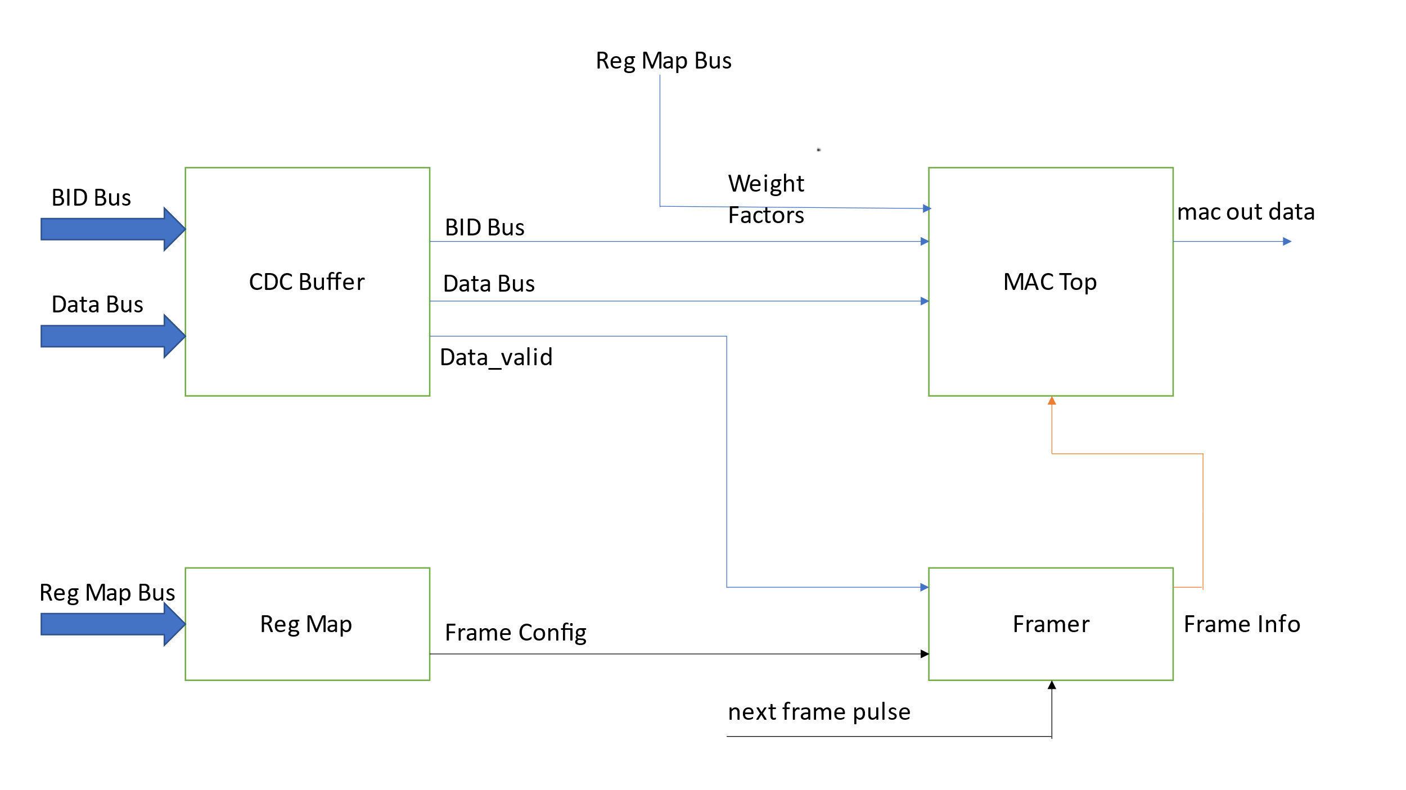

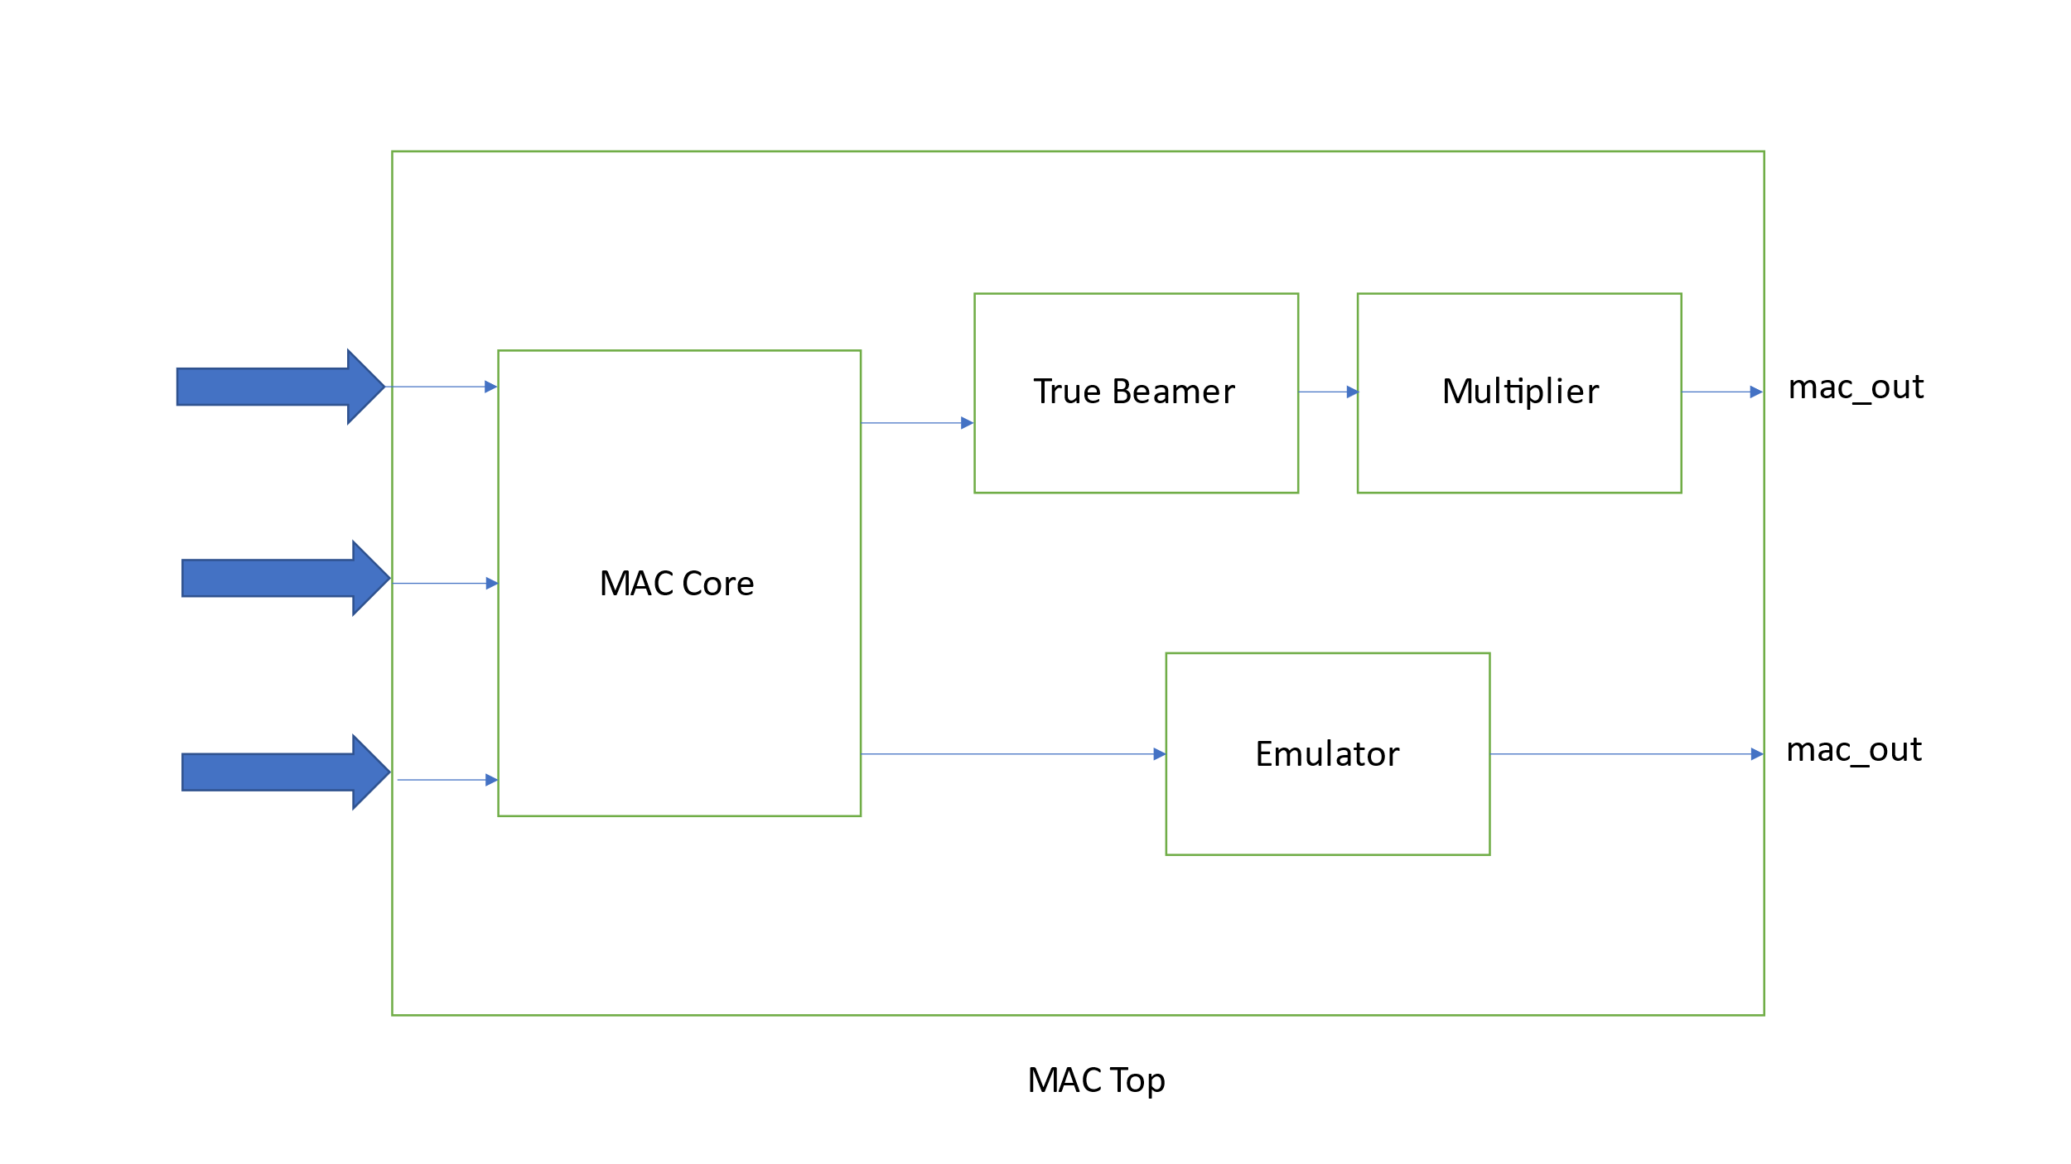

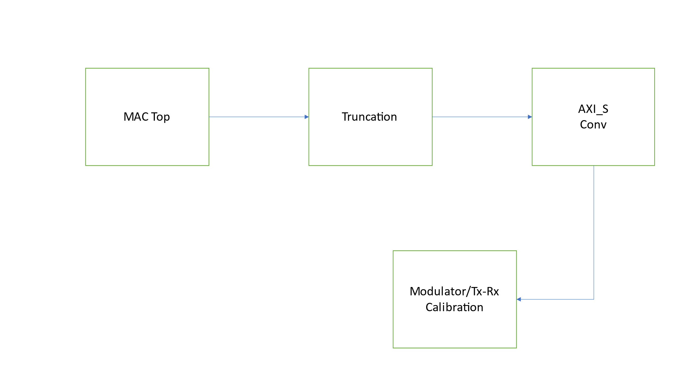

Beamforming procedure per each antenna is performed by Beam CMAC and Beam Adder modules. Therefore, DL Beamer MAC core includes 8 instances of each module according to the number of antenna ports. Number of beam cache instances is equal to the number of spatial streams because different beam vectors can be applied between different SS for the same PRBs.

U-Plane IQ data including user data, PRACH and control channels may be transmitted in compressed format. C-Plane (control plane) is a frame format that carries data used in control user data scheduling, beamforming weight selection, numerology selection, etc. The U-Plane (user plane) is a frame format that carries the user data messages between O-DU and O-RU, such as the in-phase and quadrature-phase (IQ) sample sequence of the orthogonal frequency division multiplexing (OFDM) signal.



**DL Beam CMAC scheme**

One CMAC instance performs multiplication of SS subcarriers to beam weight vector elements utilizing a single DSP48E2 block and 3 clock cycles to compute each complex multiplication. Eight DSP48E2 blocks are used in one CMAC module according to the number of SS and they are divided into two groups. One group of four DSP blocks computes only complex multiplication.



**Beam weight coefficient loading scheme**

The scheme of loading beam weight vector coefficients is presented here. One beam weight vector consists of 8 coefficients that must be read from Beam cache and set to input of the corresponded complex multiplier at a certain point in time. 16 registers are used for those purposes. 8 PRE_FF registers are connected in a daisy chain. for coefficients loading simplification. Input port of the first PRE_FF 0 register is connected to Beam Cache output. Input ports of the PRE_FF (N) registers are connected to the output of the previous PRE_FF (N-1) in the chain, where N > 0. So, loading of 8 beam weight coefficients takes at least 8 clock cycles. 8 BW_FF registers are connected to PRE_FF flip-flops and updates their value on bw_upd signal.

The first round of summation products is calculated by DL Beam CMAC module as mentioned above. The rest rounds are performed by DL Beam Adder module.



**DL Beam Adder scheme**

DL Beam Adder consists of 3 DSP48E2 blocks that calculate the sum of four elements per each I and Q component. SIMD mode of DSP48E2 block is used that allows to calculate 2 sums per one clock cycle in parallel and reduce the required number of DSP blocks. The matrix multiplication result is clipped and shifted to the right according to fixed point arithmetic parameters.



**DL beamforming signal processing scheme**

Input width of SS data samples is 16 bit and assumed signed representation and the fixed-point format of Q(16,14). Beam weights coefficients are signed and have a width of 12 bits. The fixed-point format of beam weight coefficients is Q(12,10). Data samples are multiplied with beam weight coefficients and are divided to 32 after the first round of summation fitting the result to 21 bits. This truncation in the middle is required for usage of the DSP48E2 SIMD mode during all rounds of summation. The result after the third round uses 23 bit and is converted to the required output width of 15 bits by dividing by AD1. Samples of antenna port signal have the fixed point format of Q(15,12) that matches to OFDM modulator requirements of the optimal input scale.

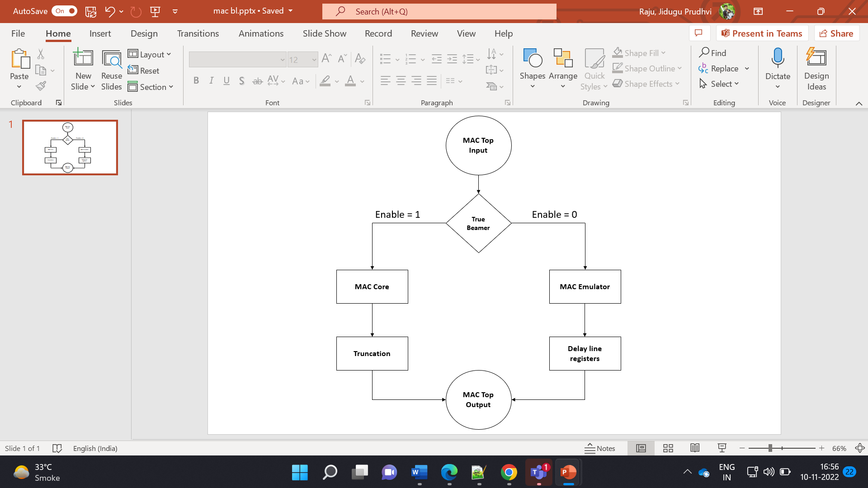

**MAC Top Processing Flowchart**

In this MAC emulator, along with IQ data inputs and output data streams, output data stream mux’s created. The MAC data inputs are given to pi/2 phase rotation emulation process. In this process, data inputs are loaded into data stream mux’s with phase rotation method. After that using delay line register module, data output stream mux’s loaded into output data stream signals.

The TX DMA signal generator is a test signal generator used for debug purposes with the test signal stored in PS DDR at input interfaces. By enabling the TM_SIG_GEN_EN, the generated output test signal connected to the MAC module, otherwise ORAN output signal connected which is coming through DSPU.

**5.4. List of Files**

List of files and corresponding modules used in this project: For detailed chart please open attached excel sheet.



|  |  |  |
| --- | --- | --- |
| **S.No** | **File Name** | **Module Name** |
| 1 | mru_beamer_dl_top.sv | mru_beamer_dl_top |
| 2 | mru_beamer_dl_dspu_pre_shifter.sv | mru_beamer_dl_dspu_pre_shifter |
| 3 | mru_beamer_dl_ctrl_top.sv | mru_beamer_dl_framer |
| 4 | mru_beamer_dl_framer.sv | mru_beamer_dl_ctrl_frame |
| 5 | mru_beamer_dl_out_conv.sv | mru_beamer_dl_out_conv |
| 6 | mru_beamer_tm_sig_gen_top.sv | mru_beamer_tm_sig_gen_top |
| 7 | mru_beamer_tm_sig_gen_ctrl.sv | mru_beamer_tm_sig_gen_ctrl |
| 8 | mru_beamer_axi_dma_top.sv | mru_beamer_axi_dma_top |
| 9 | mru_beamer_axi_dma_rd.sv | mru_beamer_axi_dma_rd |
| 10 | mru_beamer_axi_dma_rd_shift.sv | mru_beamer_axi_dma_rd_shift |
| 11 | mru_beamer_axi_dma_rd_fifo.sv | mru_beamer_axi_dma_rd_fifo |
| 12 | mru_beamer_axi_s_conv.sv | mru_beamer_axi_s_conv |
| 13 | mru_beamer_qam_gen.sv | mru_beamer_qam_gen |
| 14 | prbs_generator.sv | prbs_generator |
| 15 | mapper_top.sv | mapper_top |
| 16 | mapper.sv | mapper |
| 17 | mapper_mult.sv | mapper_mult |
| 18 | mru_beamer_dl_mac_top.sv | mru_beamer_dl_mac_top |
| 19 | mru_beamer_dl_mac_core.sv | mru_beamer_dl_mac_core |
| 20 | mru_beamer_dl_mac_beam_cache_kss.sv | mru_beamer_dl_mac_beam_cache_kss |
| 21 | mru_beamer_dl_mac_beam_cache_ss_unit.sv | mru_beamer_dl_mac_beam_cache_ss_unit |
| 22 | mru_beamer_dl_mac_kss_nap.sv | mru_beamer_dl_mac_kss_nap |
| 23 | mru_beamer_dl_mac_kss_1ap.sv | mru_beamer_dl_mac_kss_1ap |
| 24 | mru_beamer_dl_mac_2ss_1ap.sv | mru_beamer_dl_mac_2ss_1ap |
| 25 | bf_dsp48_cdot_2x1.v | bf_dsp48_cdot_2x1 |
| 26 | bf_entity_declarations.v | sysgen_counter_XXXX |
| 27 | convert_type.v | cast, shift_division_result, shift_op, pad_lsb |
| 28 | synth_reg.v | synth_reg |
| 29 | synth_reg_w_init.v | synth_reg_w_init |
| 30 | mru_beamer_dl_mac_nap_adder.sv | mru_beamer_dl_mac_nap_adder |
| 31 | mru_beamer_dl_mac_1ap_adder.sv | mru_beamer_dl_mac_1ap_adder |
| 32 | mru_beamer_dsp_simd_adder.sv | mru_beamer_dsp_simd_adder |
| 33 | mru_beamer_dl_mac_core_emul.sv | mru_beamer_dl_mac_core_emul |
| 34 | mru_beamer_beam_cache_ctrl.sv | mru_beamer_beam_cache_ctrl |
| 35 | mru_beamer_axis_fifo.sv | mru_beamer_axis_fifo |
| 36 | mru_beamer_bram.sv | mru_beamer_bram |
| 37 | mru_beamer_cdc_sync.sv | mru_beamer_cdc_sync_ack |
| 38 | mru_beamer_dclk_bram.sv | mru_beamer_dclk_bram |
| 39 | mru_beamer_dline_reg.sv | mru_beamer_dline_reg |
| 40 | mru_beamer_dp_dram.sv | mru_beamer_dp_dram |
| 41 | mru_beamer_fifo_cdc.sv | mru_beamer_fifo_cdc |
| 42 | mru_beamer_fifo_req_cdc.sv | mru_beamer_fifo_req_cdc |
| 43 | mru_beamer_if_wrap.sv |  |
| 44 | mru_beamer_interfaces.sv |  |
| 45 | mru_beamer_structures.sv |  |
| 46 | mru_beamer_tdp_bram.sv | mru_beamer_tdp_bram |
| 47 | mru_beamer_reg_map.sv | mru_beamer_reg_map |
| 48 | mru_beamer_reg_map_axi_lite_conv.sv | mru_beamer_reg_map_axi_lite_conv |
| 49 | mru_beamer_beam_cache_beamweights_proc.sv | mru_beamer_beam_cache_beamweights_proc |
| 50 | mru_beamer_fifo_uram | mru_beamer_fifo_uram |
| 51 | mru_beamer_xilinx_uram | mru_beamer_xilinx_uram |
| 52 | mru_beamer_dl_in_dspu_v2 | mru_beamer_dl_in_dspu_v2 |
| 53 | mru_beamer_asym_ram_tdp_read_first_write_wider | mru_beamer_asym_ram_tdp_read_first_write_wider |
| 54 | mru_beamer_functions | mru_beamer_functions |
| 55 | mru_beamer_ip | mru_beamer_ip |
| 56 | mru_beamer_reg_map_default_cfg | mru_beamer_reg_map_default_cfg |
| 57 | mru_beamer_reg_map_list | mru_beamer_reg_map_list |

**5.5. Configuration Data**

Configuration data of parameters and inputs: For detailed chart please open the attached excel sheet.



This configuration data is captured for **TEST_BEAM_NUMEROLOGY - 1,TEST_BEAM_BW_MHz - 100 MHz,Antenna_port_Num – 8.**

|  |  |  |  |
| --- | --- | --- | --- |
| **Reg No** | **Bits** | **From Reg Map** | **From Test bench** |
|  |  |  |  |
| 0x1 | [0] | TOTAL_KILL | 0 |
|  | [1] | DL_KILL | 0 |
|  | [2] | UL_KILL | 0 |
|  | [3] | PRACH_KILL | 0 |
|  | [4] | SRS_KILL | 0 |
|  | [5] | STAT_KILL | 0 |
|  | [6] | DL_STAT_KILL | 0 |
|  | [7] | UL_STAT_KILL | 0 |
|  |  |  |  |
| 0x2 | [0] | DL_BEAM_EN | 1 |
|  | [1] | UL_BEAM_EN | 1 |
|  | [2] | PRACH_BEAM_EN | 1 |
|  | [3] | DL_WEIGHT_SRC | 0 |
|  | [4] | UL_WEIGHT_SRC | 0 |
|  | [5] | PRACH_WEIGHT_SRC | 0 |
|  | [15:8] | DL_BEAM_ID_NUM | 8'd1 |
|  | [23:16] | UL_BEAM_ID_NUM | 8'd1 |
|  | [31:24] | PRACH_BEAM_ID_NUM | 8'd1 |
|  |  |  |  |
| 0x3 | [1:0] | DL_BEAM_EMUL_SCENARIO | 2'b00 |
|  | [3:2] | UL_BEAM_EMUL_SCENARIO | 2'b00 |
|  | [5:4] | PRACH_BEAM_EMUL_SCENARIO | 2'b00 |
|  | [6] | UL_MAC_EMUL_MODE | 1'b0 |
|  | [7] | PRACH_DEMOD_EMUL_MODE | 1'b0 |
|  | [8] | DL_DSPU_MULTISTR_MODE | 1'd1 |
|  | [9] | UL_OFPU_SLEEP_MODE | 1'd0 |
|  | [12:10] | DL_BEAM_SHIFT | 3'd0 |
|  | [20] | DL_BC_BID_SRC | 1'd0 |
|  | [21] | PRACH_BC_BID_SRC | 1'd0 |
|  | [22] | dl_beamweights_en | 1'd0 |
|  | [23] | ul_beamweights_en | 1'd0 |
|  | [24] | Ul_bc_bid_src | 1'd0 |
|  |  |  |  |
| 0x4 | [0] | DL_UDCOMPHDR_RMV | 1'b0 |
|  | [1] | DL_IQ_BYTE_SWAP | 1'b0 |
|  | [2] | UL_UDCOMPHDR_ADD | 1'b0 |
|  | [3] | UL_IQ_BYTE_SWAP | 1'b0 |
|  | [4] | PRACH_UDCOMPHDR_ADD | 1'b0 |
|  | [5] | PRACH_IQ_BYTE_SWAP | 1'b0 |
|  | [6] | SRS_UDCOMPHDR_ADD | 1'b0 |
|  | [7] | SRS_IQ_BYTE_SWAP | 1'b0 |
|  |  |  |  |
|  |  |  |  |
| 0x5 | [1:0] | PRACH_IN_CH_MASK | 2'b00 |
|  | [2] | PRACH_OCCASIONS_NUM | 1'b0 |
|  | [4:3] | DL_OUT_CH_MASK | 2'b11 |
|  | [6:5] | UL_OUT_CH_MASK | 2'b00 |
|  |  |  |  |
| 0x6 | [15:0] | DL_ORAN_DATA_TO | 16'd500 |
|  |  |  |  |
| 0x7 | [0] | DL_ORAN_TREADY_ONE | 1'b1 |
|  |  |  |  |
| 0x8 | [3:0] | DL_SUBFRAME_NUM | 4'd2 |
|  | [11:4] | DL_SLOTS_NUM | 8'd20 |
|  | [15:12] | DL_SYMB_NUM | 4'd14 |
|  | [24:16] | DL_RB_NUM | 9'd273 |
|  | [28:25] | DL_SC_NUM | 4'd12 |
|  |  |  |  |
| 0x9 | [12:0] | DL_SYMB_FFT_SIZE | 13'd4096 |
|  |  |  |  |
| 0xA | [3:0] | UL_SUBFRAME_NUM | 4'd2 |
|  | [11:4] | UL_SLOTS_NUM | 8'd20 |
|  | [15:12] | UL_SYMB_NUM | 4'd14 |
|  | [24:16] | UL_RB_NUM | 9'd273 |
|  | [28:25] | UL_SC_NUM | 4'd12 |
|  |  |  |  |
| 0xB | [12:0] | UL_SYMB_FFT_SIZE | 13'd4096 |
|  |  |  |  |
| 0xC | [15:0] | PRACH_PREAMB_LEN | 16'd139 |
|  |  |  |  |
| 0x10 | [0] | TEST_SIG_GEN_EN | 1'd0 |
|  | [1] | TEST_SIG_SRC | 1'd1 |
|  | [9:2] | TEST_EXAC_EN_MASK | 8'd1 |
|  | [11:10] | TEST_INT_MOD_TYPE | 2'd3 |
|  | [14:12] | TEST_TM_INDX | 3'b0 |
|  |  |  |  |
| 0x11 | [31:0] | TEST_TM11_DDR_ADDR | 32'd0 |
| 0x12 | [31:0] | TEST_TM12_DDR_ADDR | 32'd4194304 |
| 0x13 | [31:0] | TEST_TM2_DDR_ADDR | 32'd83,88,608 |
| 0x14 | [31:0] | TEST_TM2A_DDR_ADDR | 32'd12582912 |
| 0x15 | [31:0] | TEST_TM31_DDR_ADDR | 32'd16777216 |
| 0x16 | [31:0] | TEST_TM31A_DDR_ADDR | 32'd20971520 |
| 0x17 | [31:0] | TEST_TM32_DDR_ADDR | 32'd25165824 |
| 0x18 | [31:0] | TEST_TM33_DDR_ADDR | 32'd29360128 |
| 0x19 | [31:0] | TEST_TM_LENGTH | 32'd917280 |
|  |  |  |  |
| 0x20 | [0] | BC_OP_TYPE | 1'd0 |
|  | [2:1] | BC_TABLE_SEL | 2'd1 |
|  | [15:3] | BC_TABLE_ADDR | 13'd0 |
|  |  |  |  |
| 0x21 | [23:0] | BC_TABLE_VAL |  |
| 0x27 | [31:0] | BC_SS_BID[3:0] | 0x03020100 |
| 0x28 | [31:0] | BC_SS_BID[7:4] | 0x07060504 |
|  |  |  |  |
| 0x29 | [6:0] | PRACH_BID | 7'd32 |
| 0x2A | [2:0] | PRACH_BEAMER_OUT_LSHIFT | 3'd0 |
|  |  |  |  |
|  |  | **SRS Related Registers** |  |
| 0x50 | [5:0] | SRS_PROC_ANT_NUM | 6'd0 |
| 0x50 | [14:6] | SRS_PROC_SYM_NUM | 9'd279 |
| 0x50 | [18:15] | ORAN_SUBFRAME_ID | 4'd9 |
| 0x50 | [24:19] | ORAN_SLOT_ID | 6'd1 |
| 0x50 | [30:25] | ORAN_SYMB_ID | 6'd13 |
|  |  |  |  |
| 0x51 | [11:0] | ORAN_SECTION_ID | 12'd0 |
| 0x51 | [15:12] | ORAN_FILTER_INDEX | 4'd0 |
| 0x51 | [18:16] | ORAN_PAYLOAD_VERSION | 3'd0 |
| 0x51 | [19:19] | ORAN_DATA_DIRECTION | 1'd0 |
| 0x51 | [21:20] | ORAN_ORAN_RB | 2'd0 |
| 0x51 | [22:22] | ORAN_ORAN_SYM_INC | 1'd0 |
|  |  |  |  |
| 0x52 | [7:0] | SRS_PROC_PRB_NUM | 8'd255 |
| 0x52 | [15:8] | SRS_PROC_PRB_NUM_LAST | 8'd18 |
| 0x52 | [19:16] | SRS_PROC_ETH_PACKET_NUM | 4'd2 |
|  |  |  |  |
| 0x53 | [12:0] | SRS_PROC_DATA_LENGTH | 13'd7148 |
| 0x53 | [25:13] | SRS_PROC_DATA_LENGTH_LAST | 13'd512 |
|  |  |  |  |
| 0x54 | [9:0] | SRS_PROC_RD_ADDR_MAX | 10'd894 |
| 0x54 | [19:10] | SRS_PROC_RD_ADDR_MAX_LAST | 10'd64 |

**5.6. Configuration Analysis**

* Bid source is enabled high with 1. So, the DL took BID data from reg map.
* 1 frame is executed with 20 slots and 14 symbols for each slot as per 5G standards
* 8 Data Streams are generated to configure the antenna ports
* True Beamer is enabled high, so dspu data goes to the mac core instead of mac emulator.
* DL Beamer emulation scenario is given 0 as default. So even if emulator is enabled, the data will perform Round-robin of 8 input eAxC to 32 antennas. To perform of Pi/2 rotation per each of 8 eAxC, emul scenario given as 1.
* DL beam shift is given 0 as default, when its going for 1 the I and q data would be rotate for each scenario based on the beam shift.
* DL Beamer DSPU multi stream mode (wait data readiness of other DSPUs) (not active now!!!): 0 – disable, 1 – enable
* Current Antenna port number is 32. Also checked the simulation for 2,4,8
* Beam cache size is 256. 273 physical resource blocks are used per symbol
* DSPU_NEXT_FRAME_CNTR ---> Number of frames in DL DSPU
* DSPU_NEXT_SLOT_CNTR ---> Number of slots in DL DSPU
* DSPU_0_EMPTY_SLOT_CNTR ---> Number of empty slots for DSPU 0 when BID params didn’t come
* DSPU_0_BID_PARAMS_CNTR ---> Number of BID params transactions which came to DSPU 0
* DSPU_0_INPUT_PACKET_CNTR ---> Number of data packets which came to DSPU 0
* DSPU_0_OUTPUT_PACKET_CNT ---> Number of data packets which came from CDC unit in DSPU 0
* DSPU_0_END_OFDM_SYMB_MISM ---> Number of incorrect OFDM symbols in DSPU 0
* DSPU_0_INC_TUSER_SYMB_MISM ---> Number of samples with incorrect TUSER in DSPU 0
* DSPU_0_EMPTY_SYMB_EXC ---> Number of slots when data came with long delay in DSPU 0

**6. SYNTHESIS**

**6.1. Schematic Block Diagram**

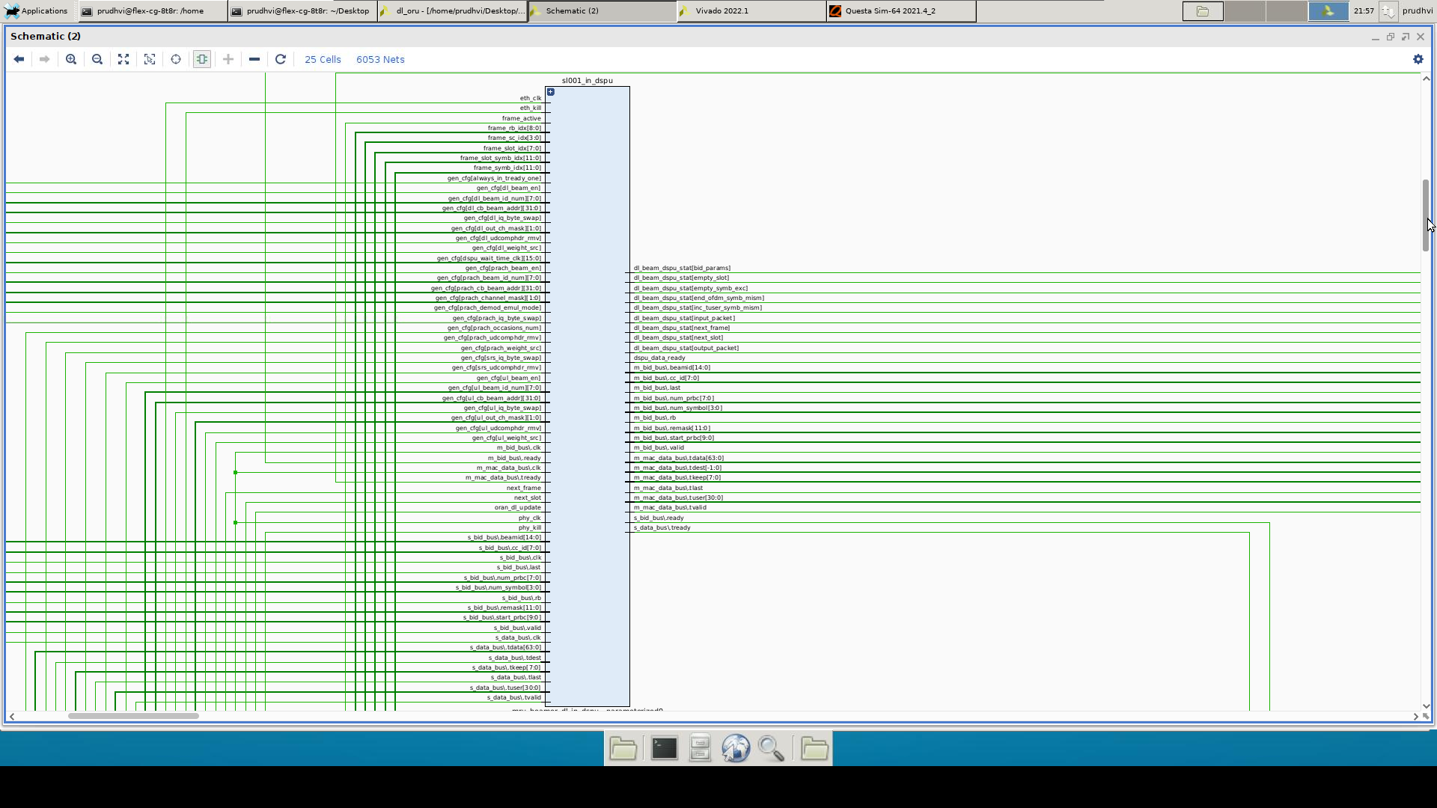

**DSPU Block**

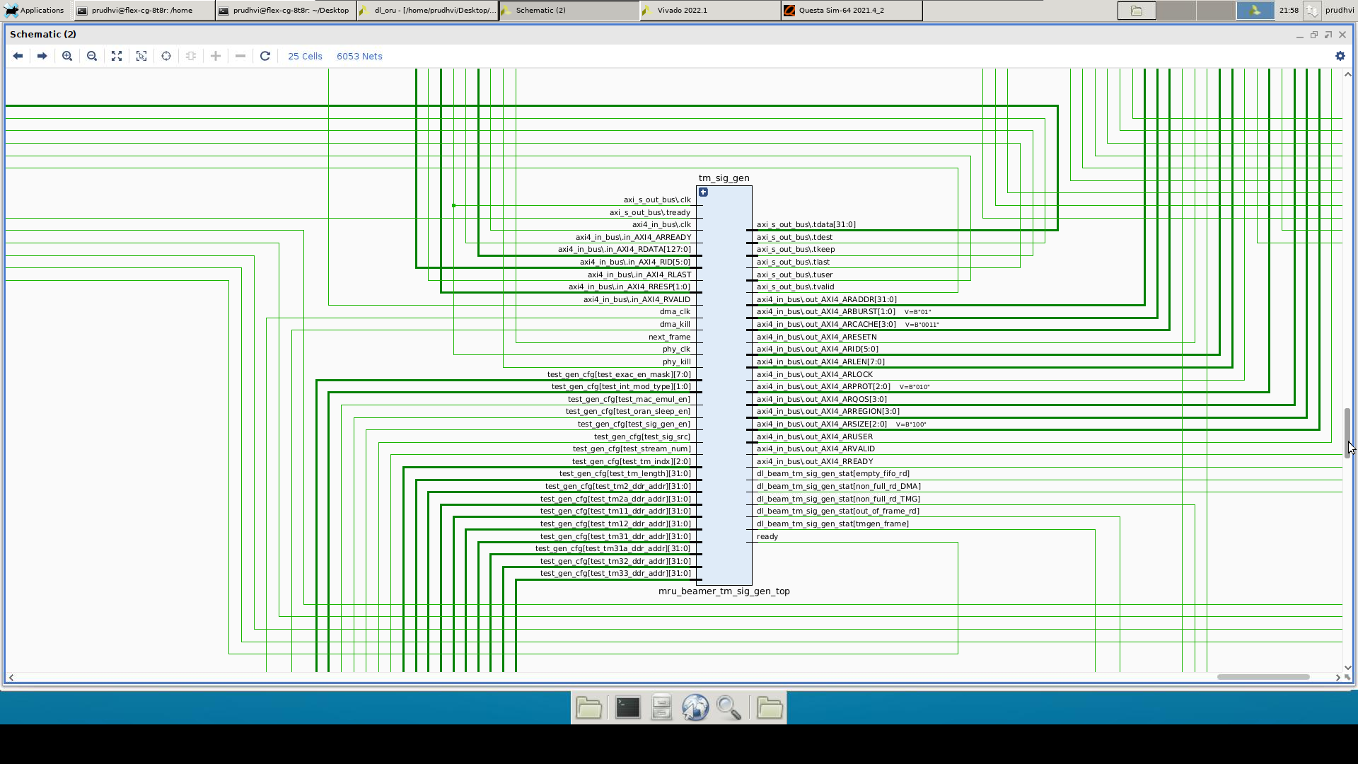

**TM Signal Generator**

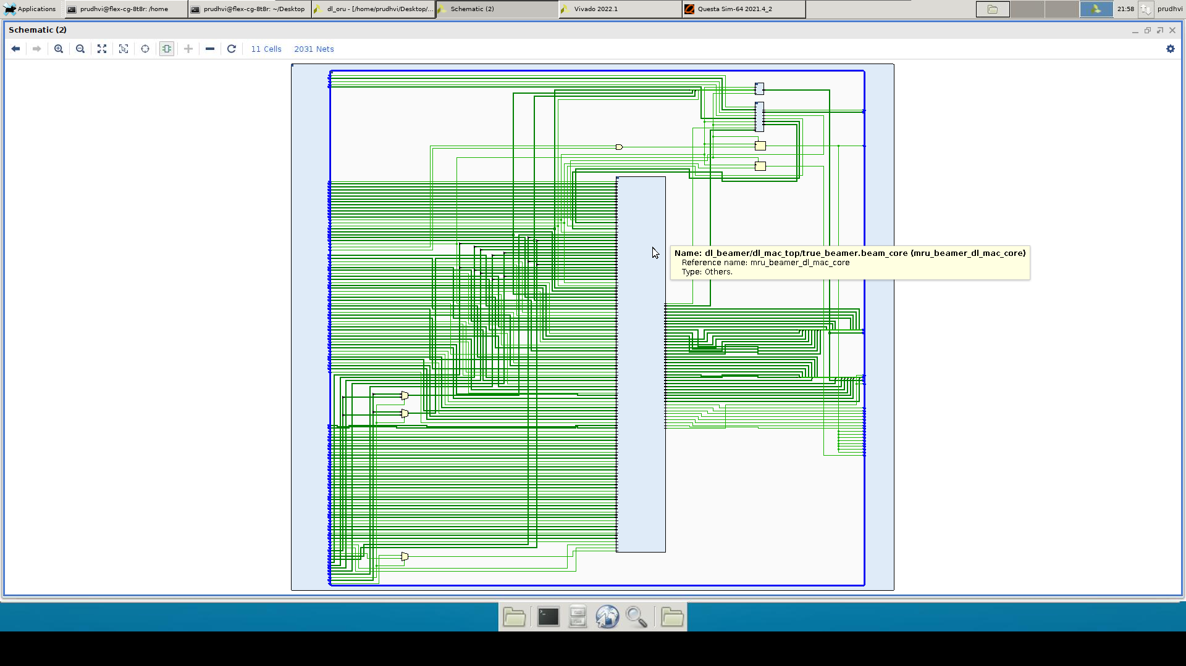

**DL MAC Top**

**6.2. Synthesis Reports**

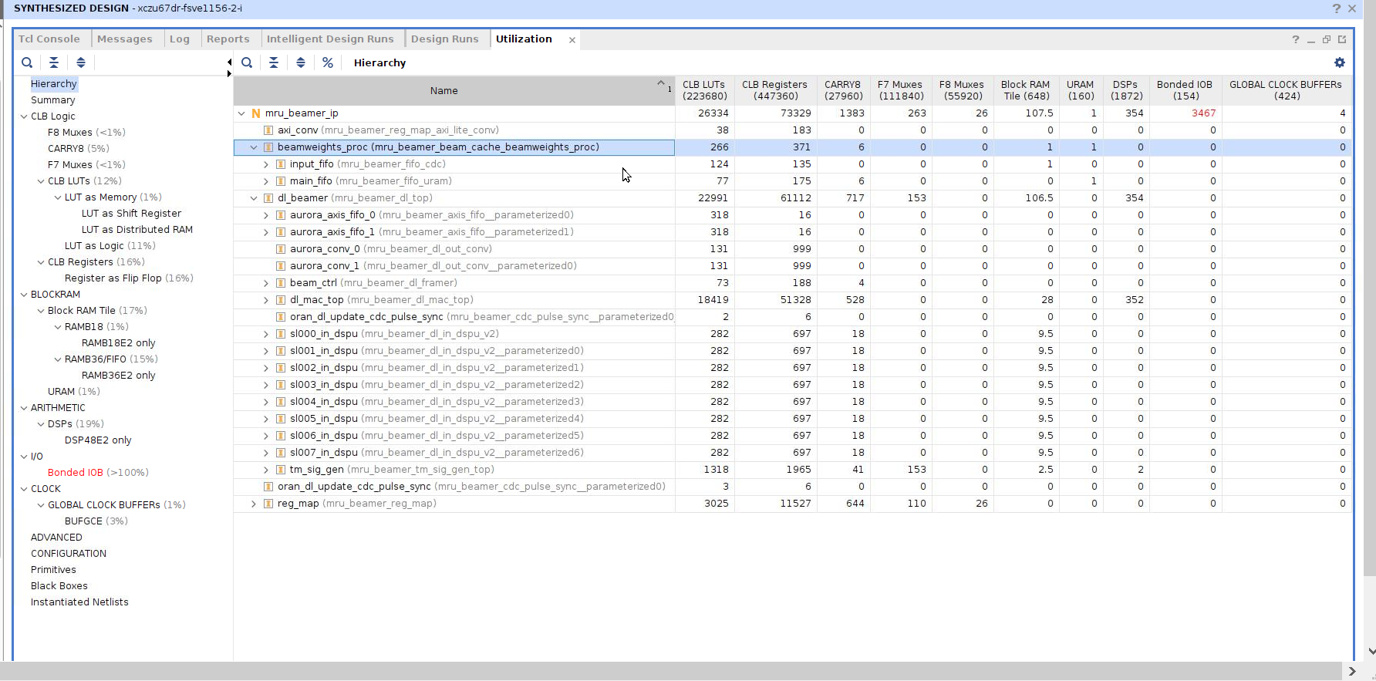

Please check the utilization reports file below





**7. SIMULATION**

Antenna Port Configuration (AP_NUM): 2

Simulation ran for 1 frame 20 slots14 symbols.

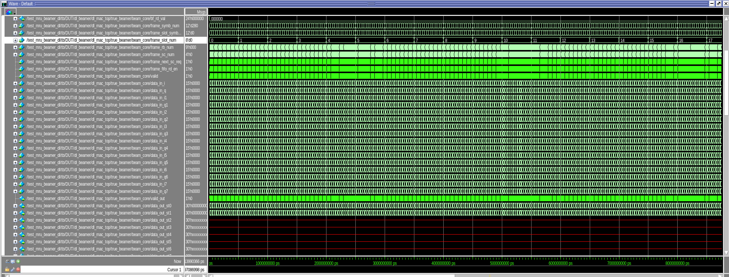

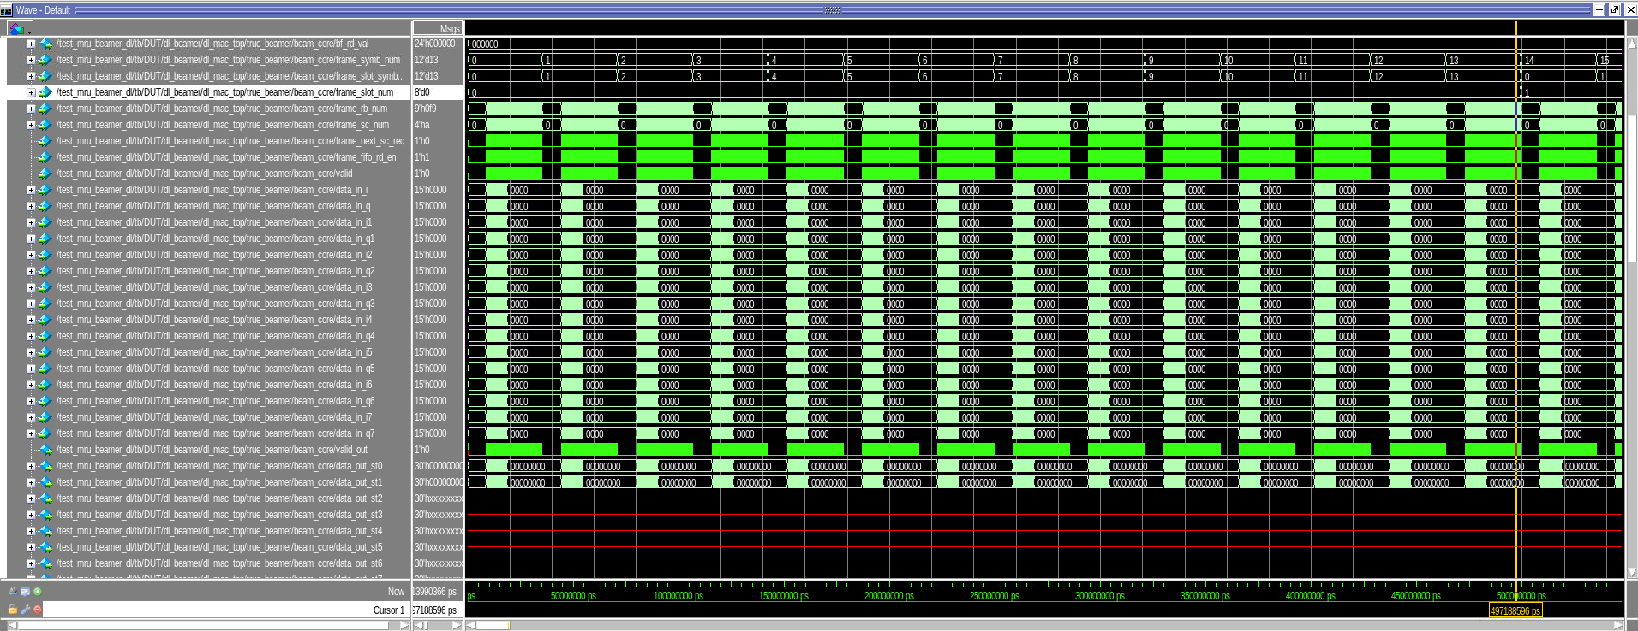

Antenna Port Configuration (AP_NUM): 4

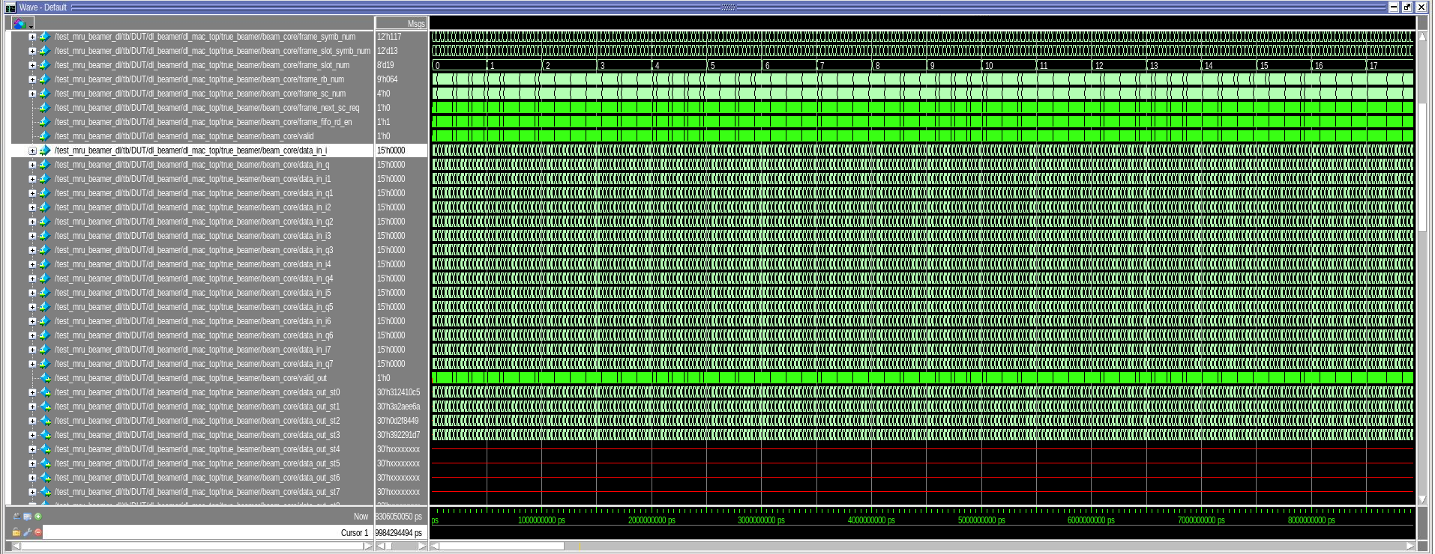

Simulation ran for 1 frame 20 slots14 symbols.

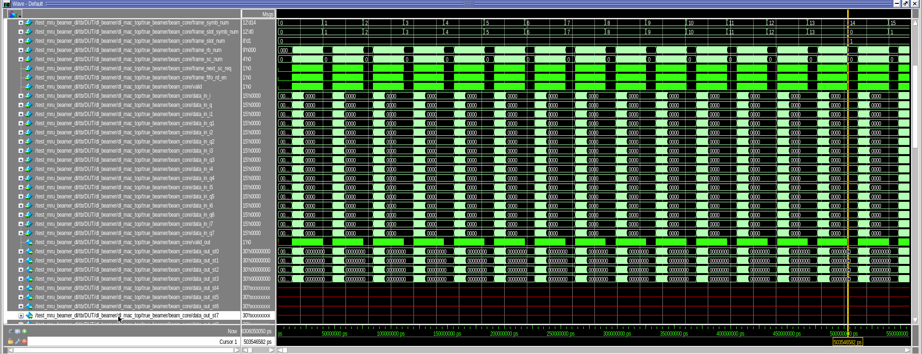

Antenna Port Configuration (AP_NUM): 8

Simulation ran for 1 frame 20 slots14 symbols.

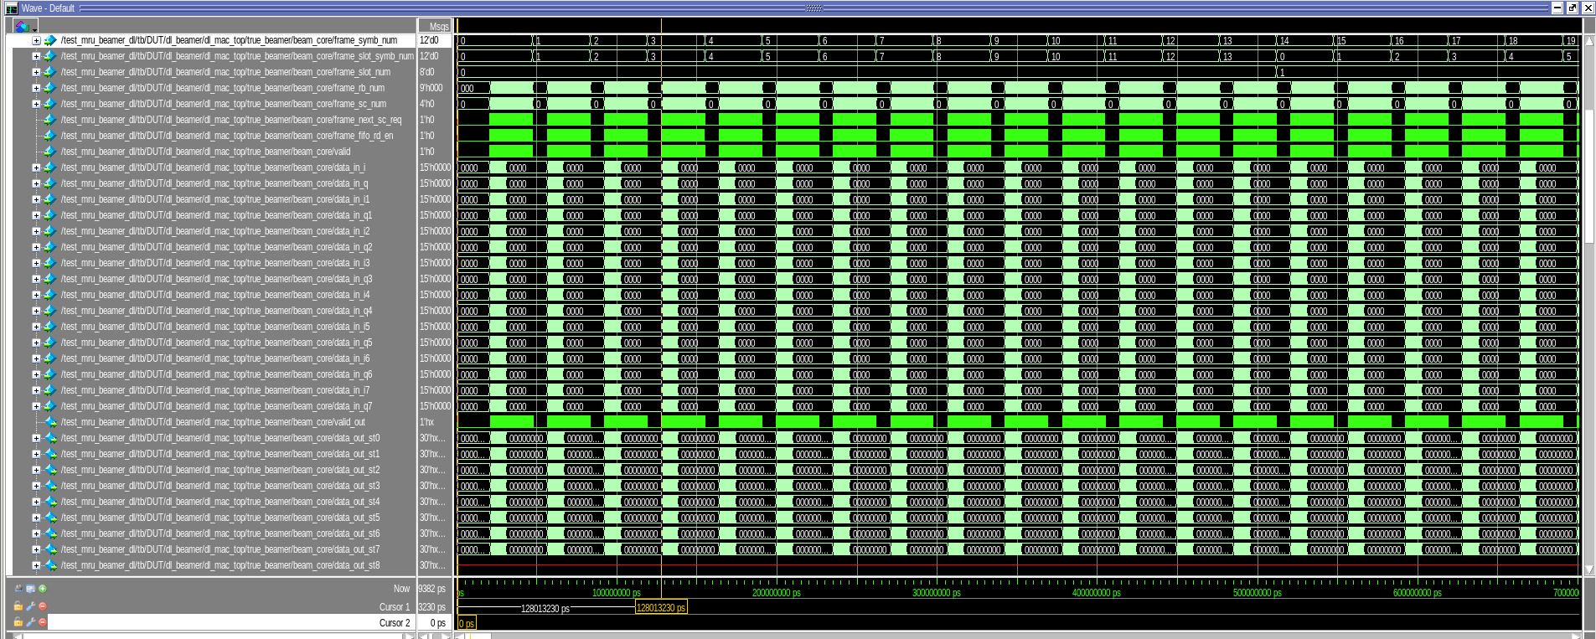

Antenna Port Configuration (AP_NUM): 32

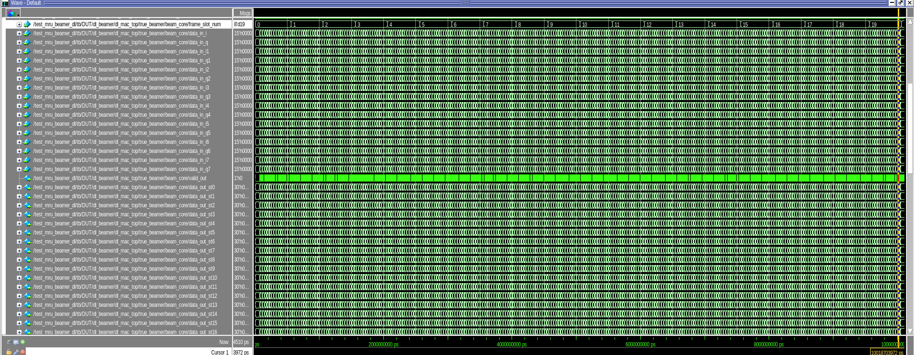

Simulation ran for 1 frame 20 slots14 symbols.

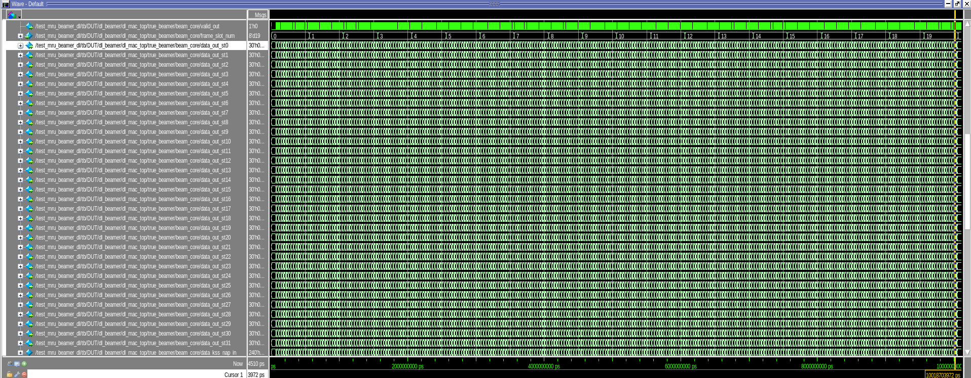

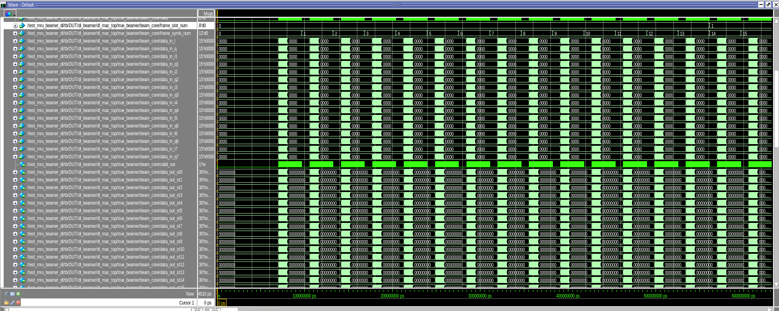

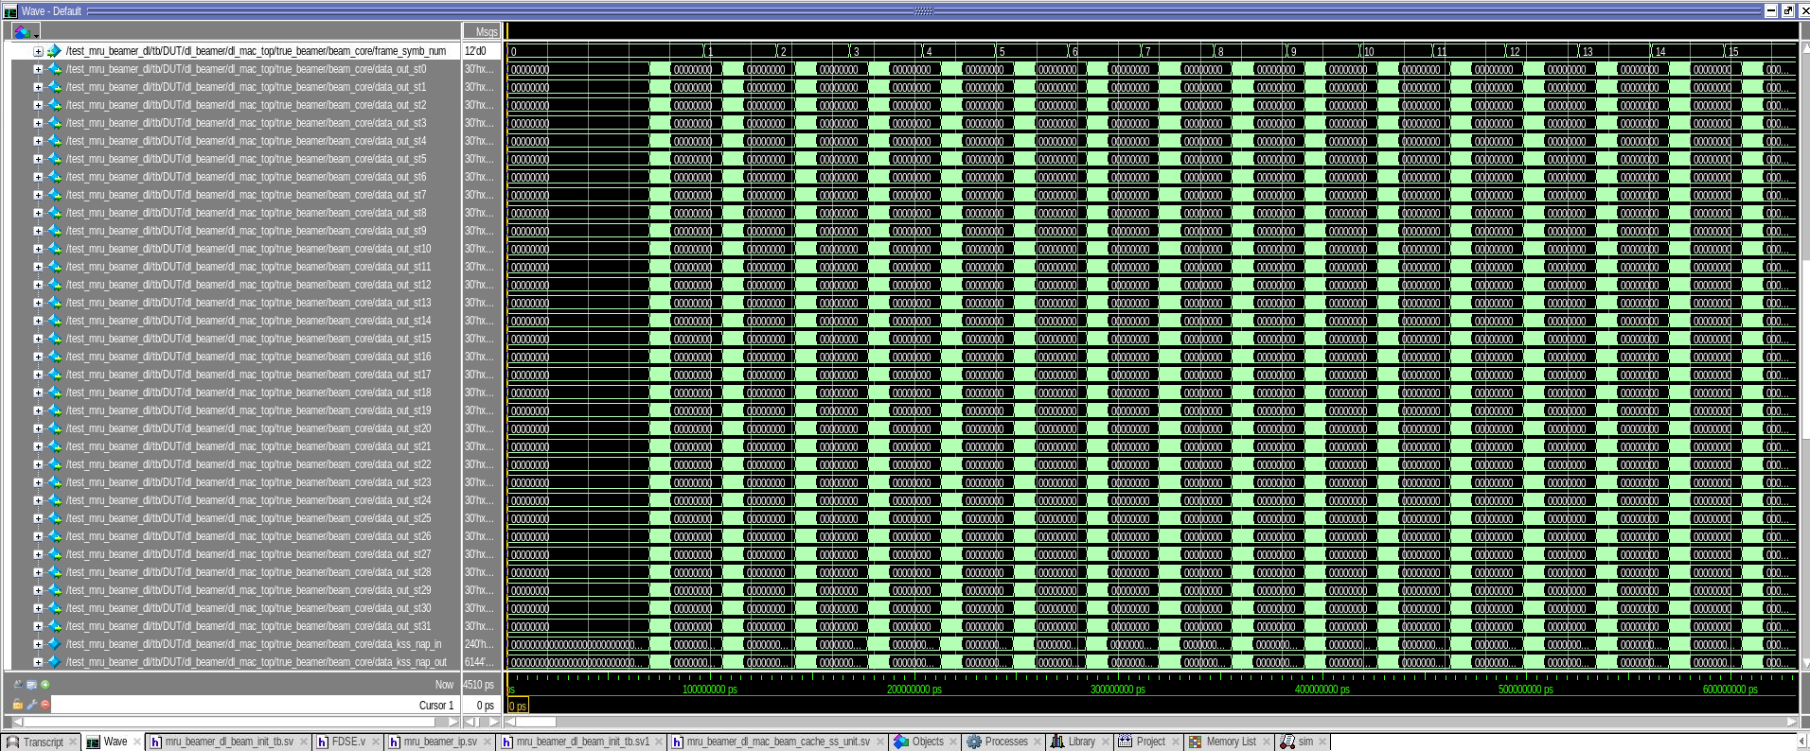

DL Beamer Output Data:

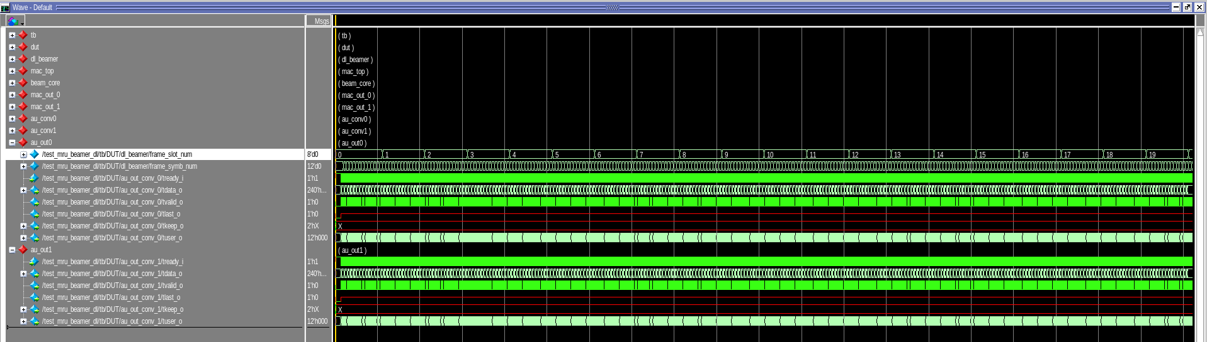

**Output data for 20 slots (1 frame)**

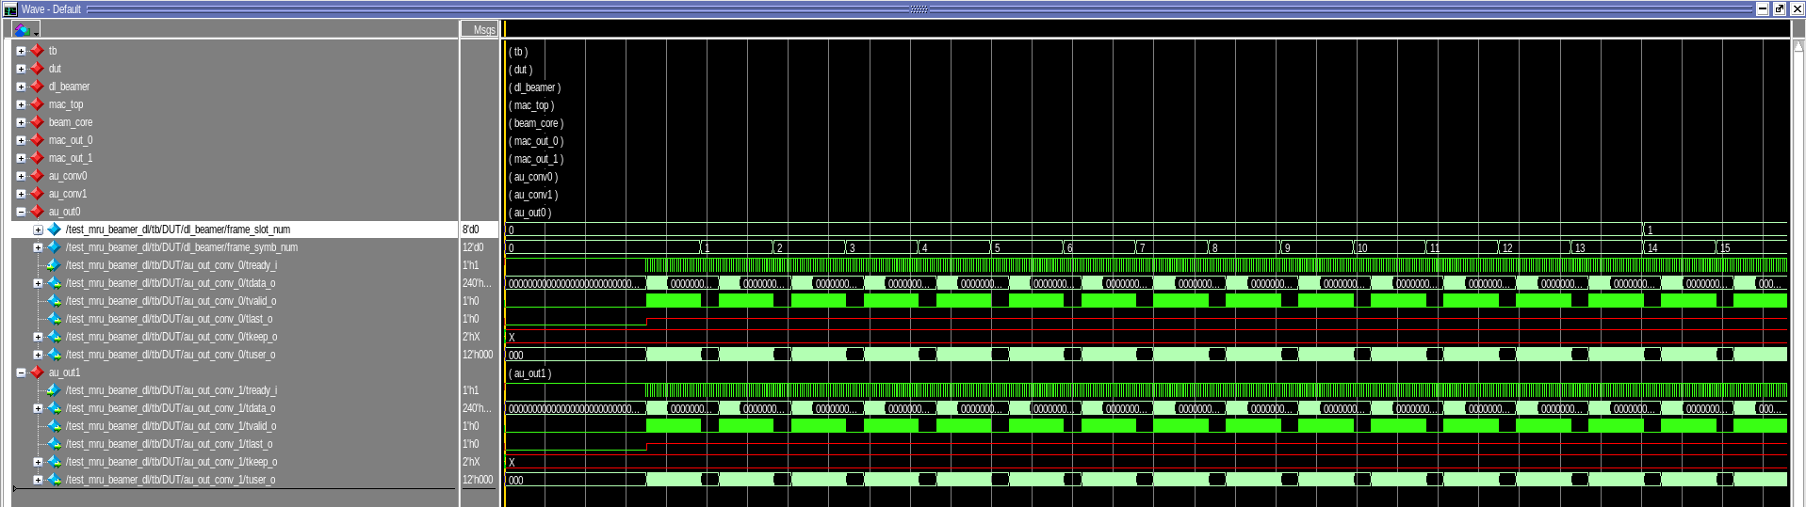

**Output data for 14 symbols (1 slot (1 frame))**

Transcript Window:

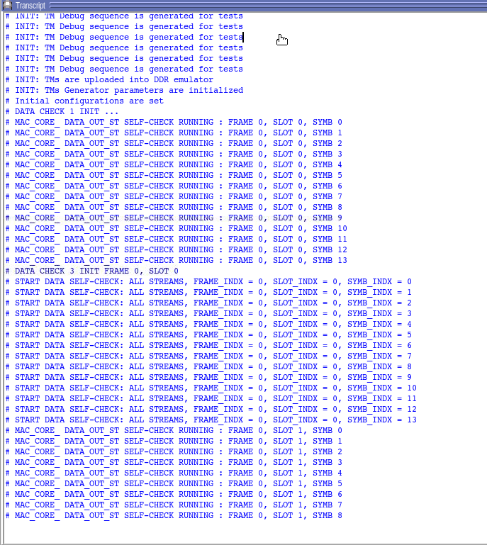

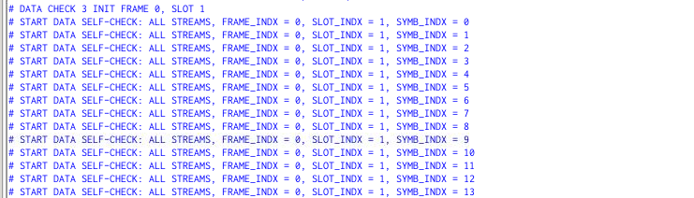

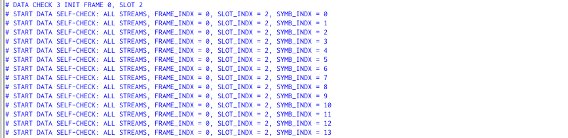

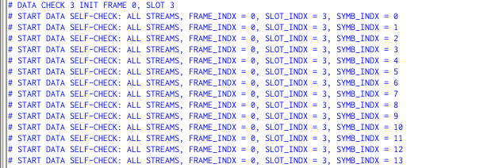

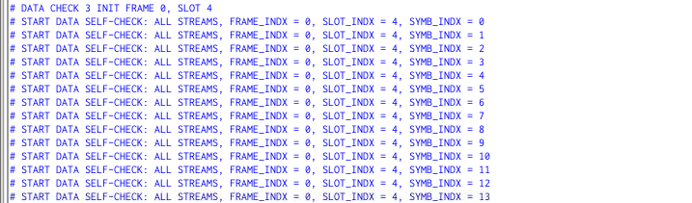

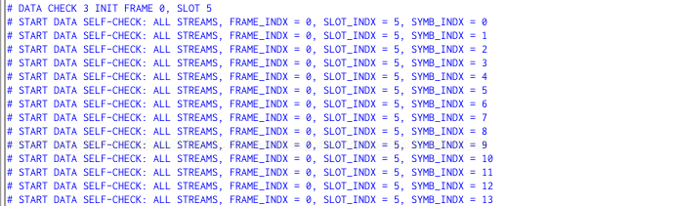

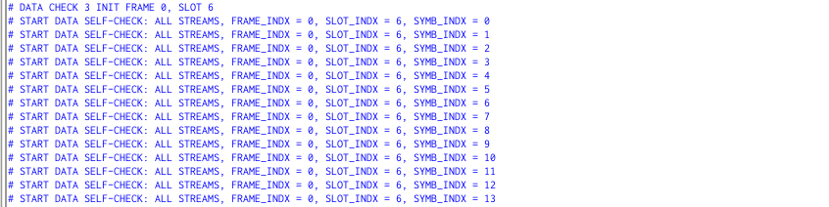

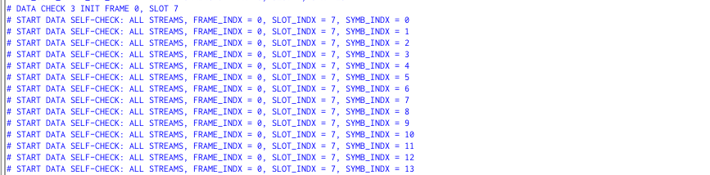

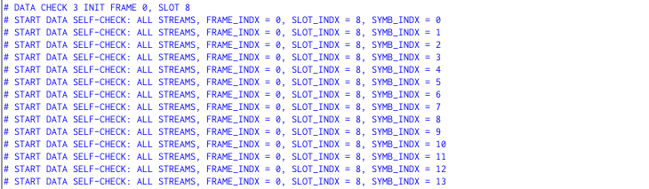

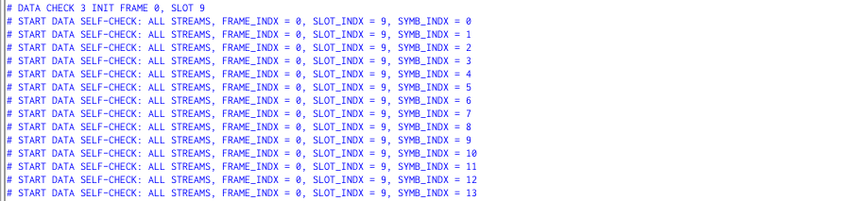

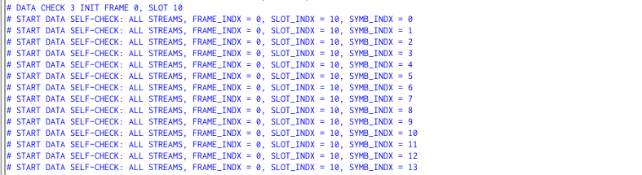

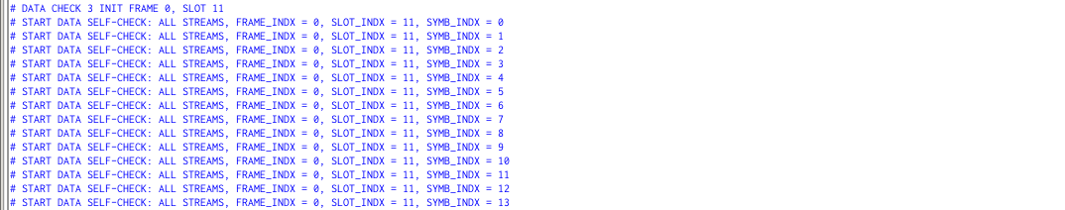

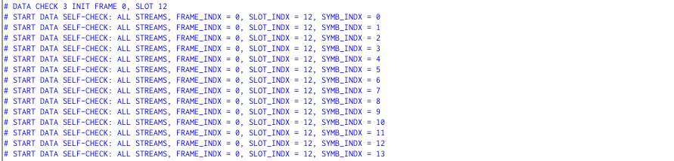

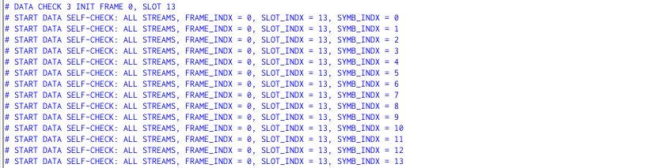

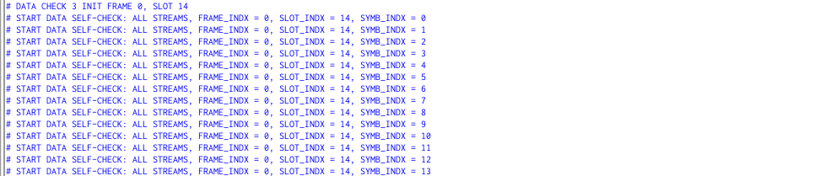

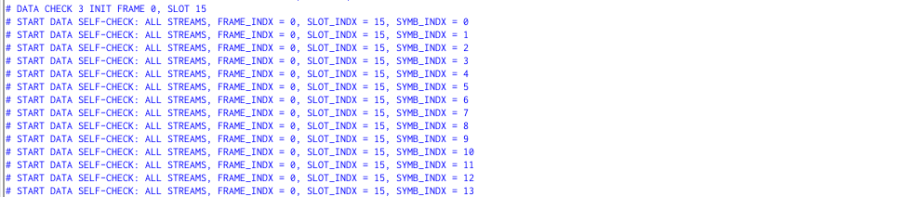

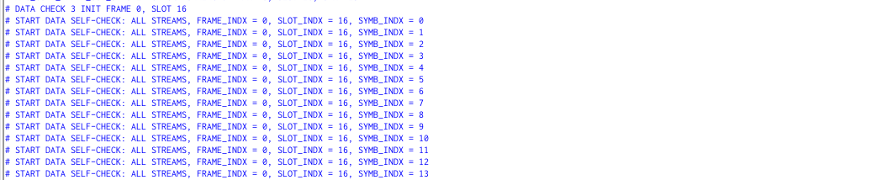

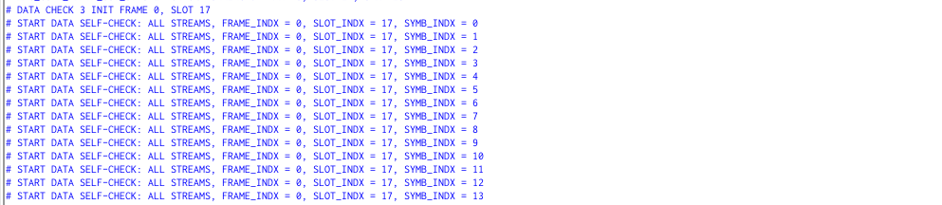

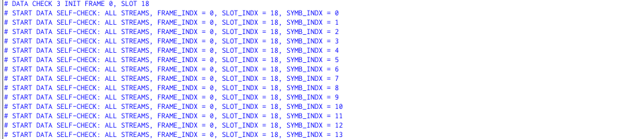

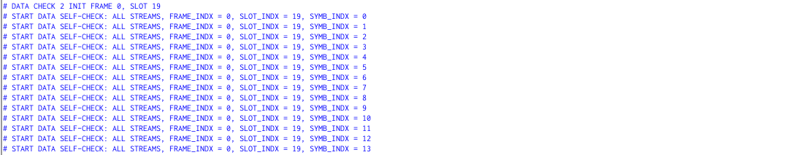

**8. Modifications**

1) CG old code is for 32 antenna port configurations only. Modified the parameter AP_NUM with 2,4,8,16 also. Design simulation is running for all cases.

2) Numerology changed from 1 to 0. This modification also running successfully.

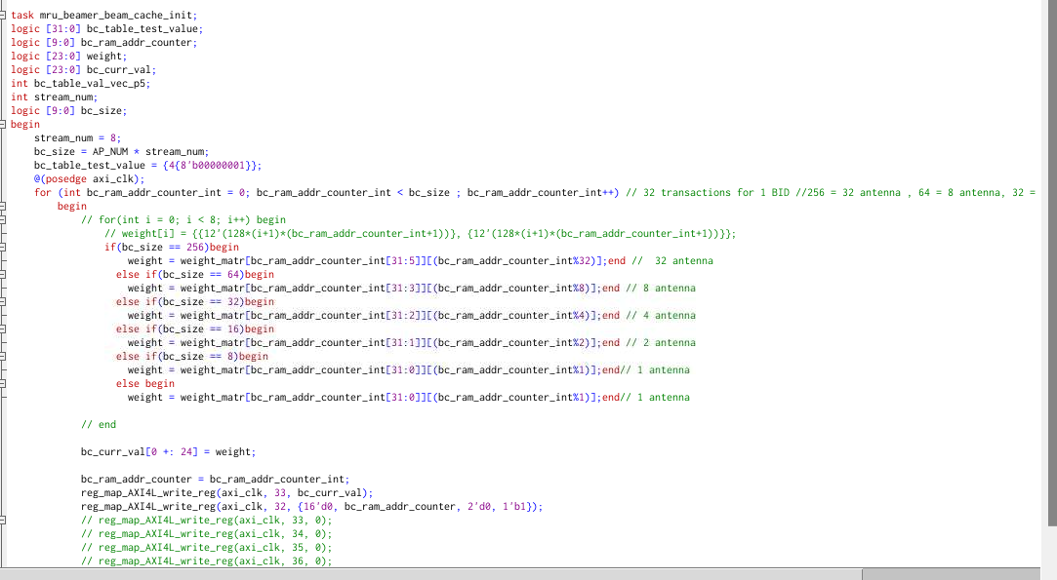

3) Bandwidth is changed from 100Mhz to other frequencies:

BW: 100Mhz, AP_NUM: 32

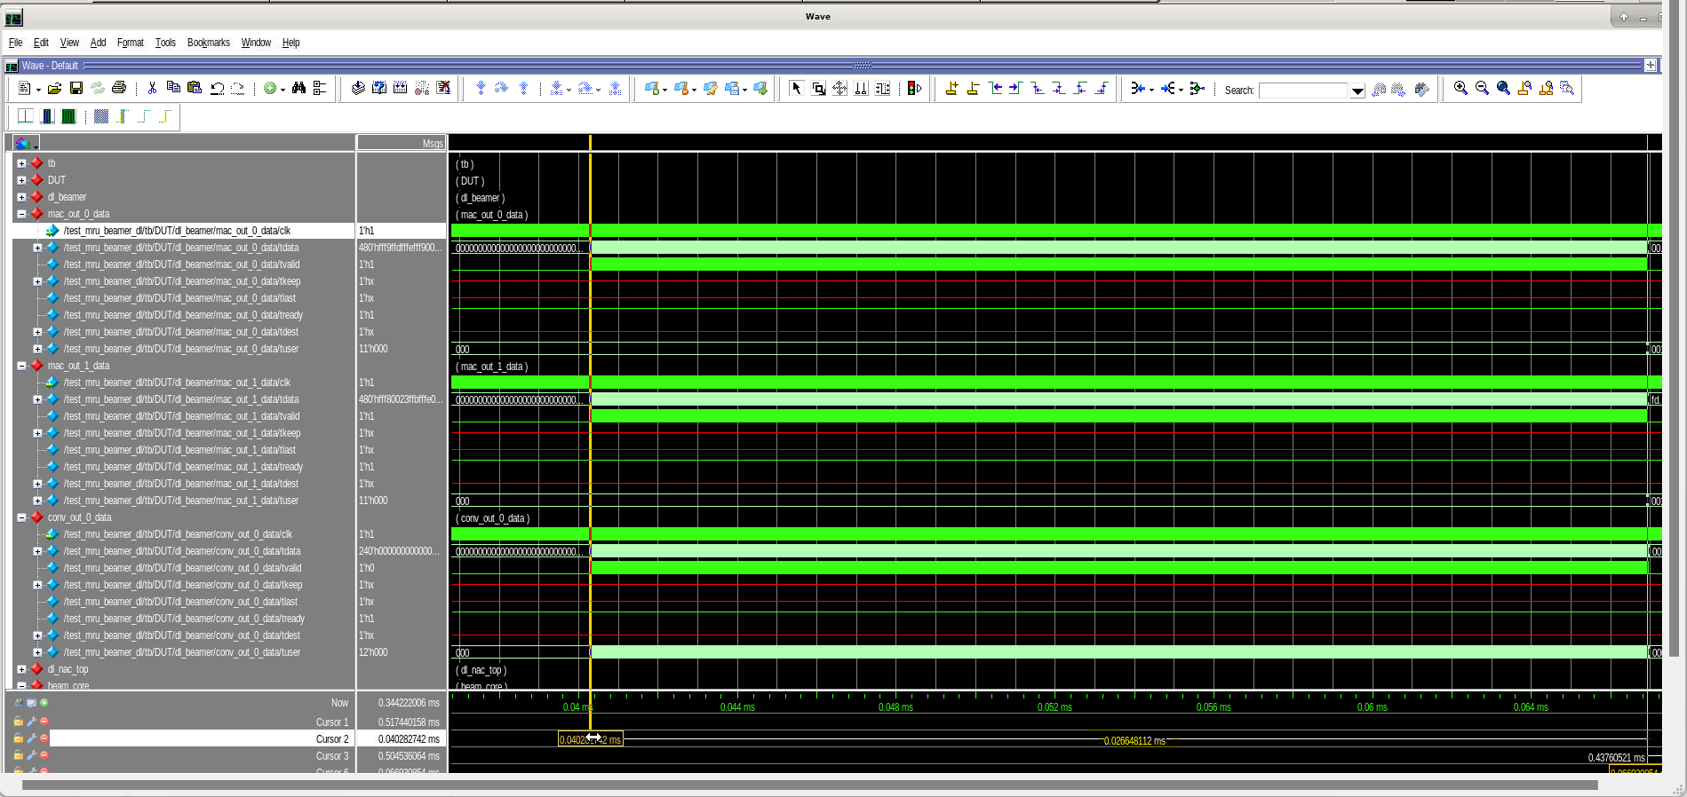

BW: 100Mhz, AP_NUM: 8

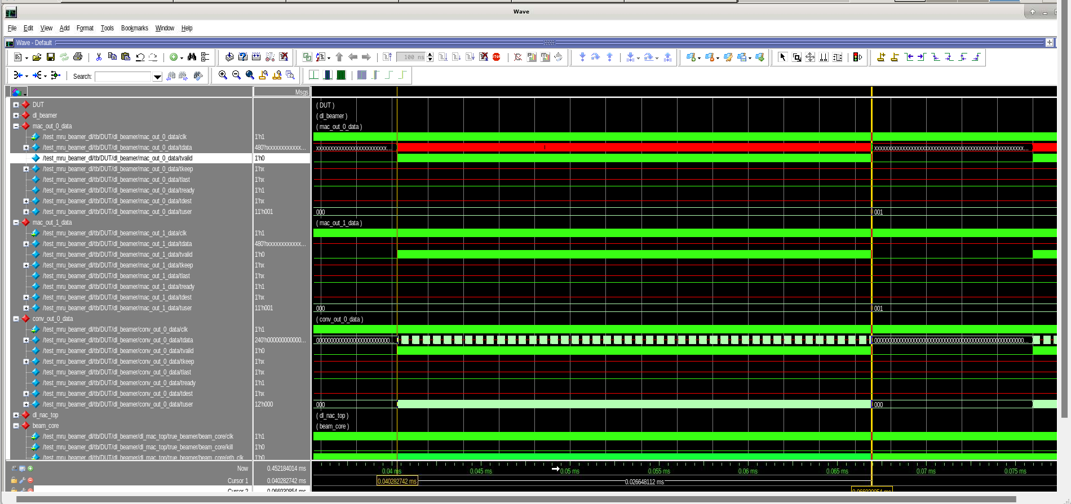

1 clk pulse = 2725 ps

1 transaction time(240 bits = 8*30 bits) = 3 clks = 3*2725 ps

For 1 transaction of symbol at 1 sub carrier, time period = 3*2725ps = 8175ps

For 100Mhz, 273 PRB’s exists. Each PRB has 12 Sub carriers

So, 273 x 12 = 3276 transactions

3276 x 8175ps = 26781300 ps = 26.781300 us

For 1 symbol covers all PRB’s with time period of 26.7813 us

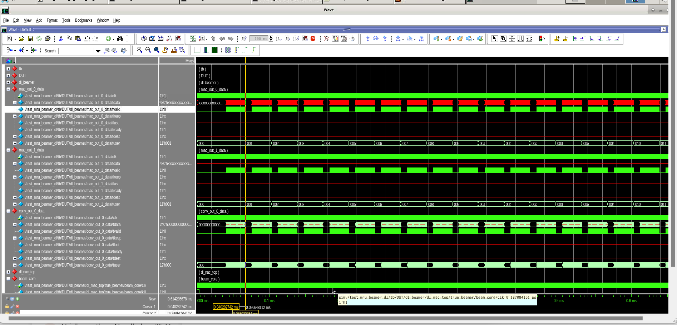

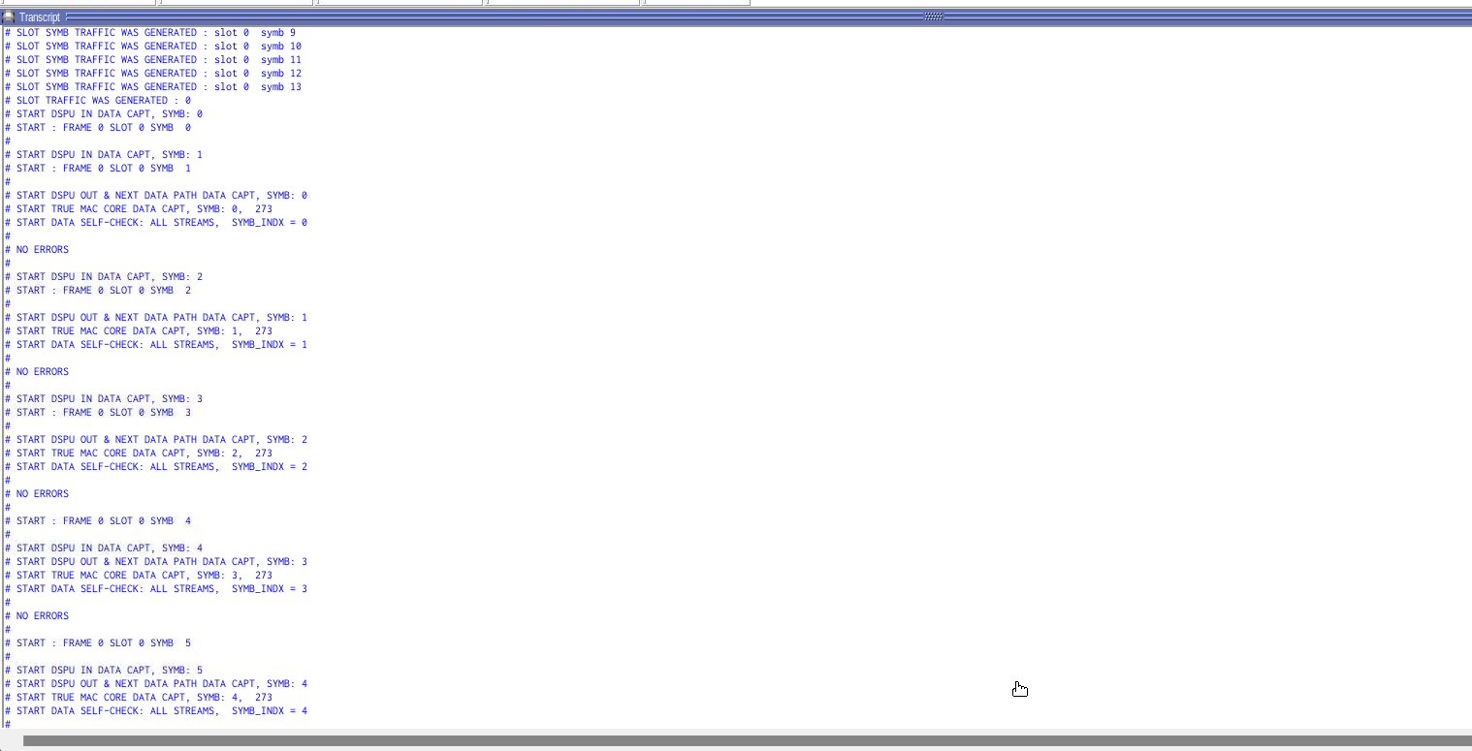

BW: 50Mhz, AP_NUM: 8

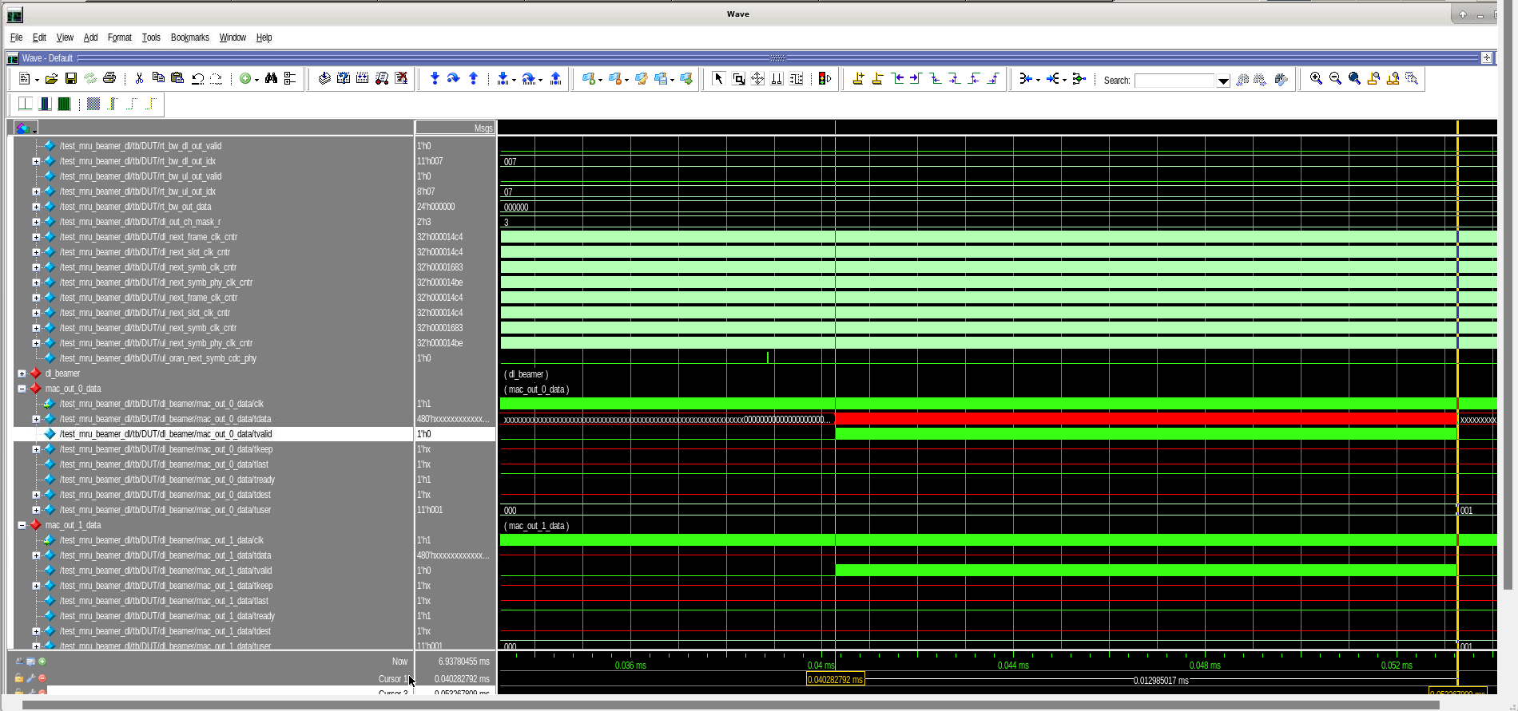

BW: 40Mhz, AP_NUM: 8

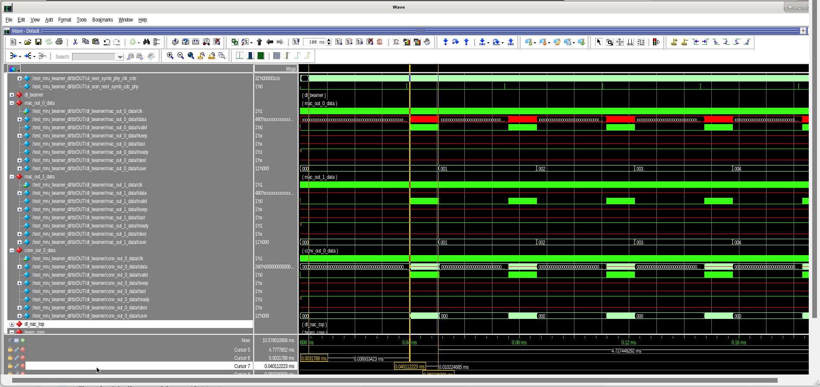

Input & Output capture

First sub carrier input transaction starts at time period = 0.0031788ms

First sub carrier output transaction starts at time period = 0.040112223ms

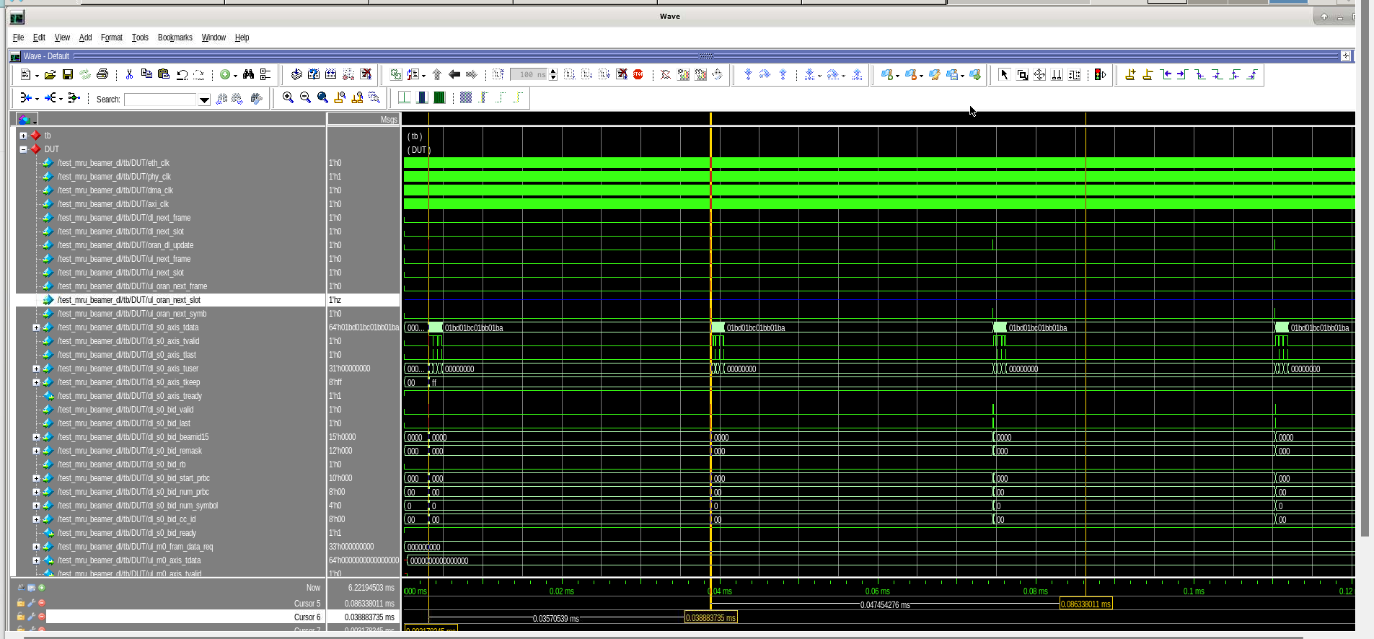

Delay between 1st input & 2nd input = 0.03570539ms

1st input starts at 0.003178845ms

2nd input starts at 0.038883735ms

BW: 100Mhz, AP_NUM: 4

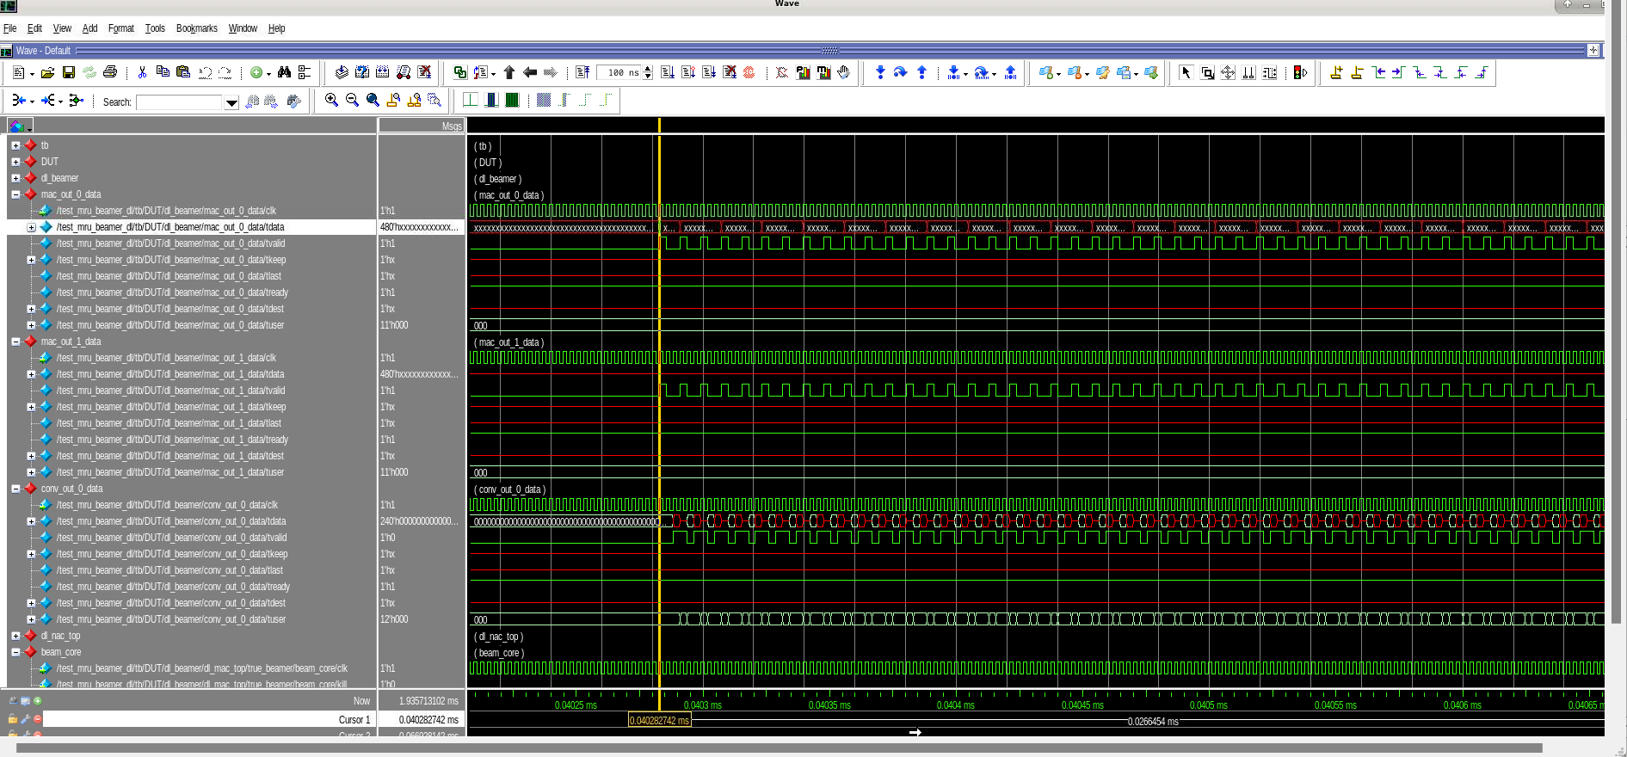

BW: 5Mhz, AP_NUM: 8

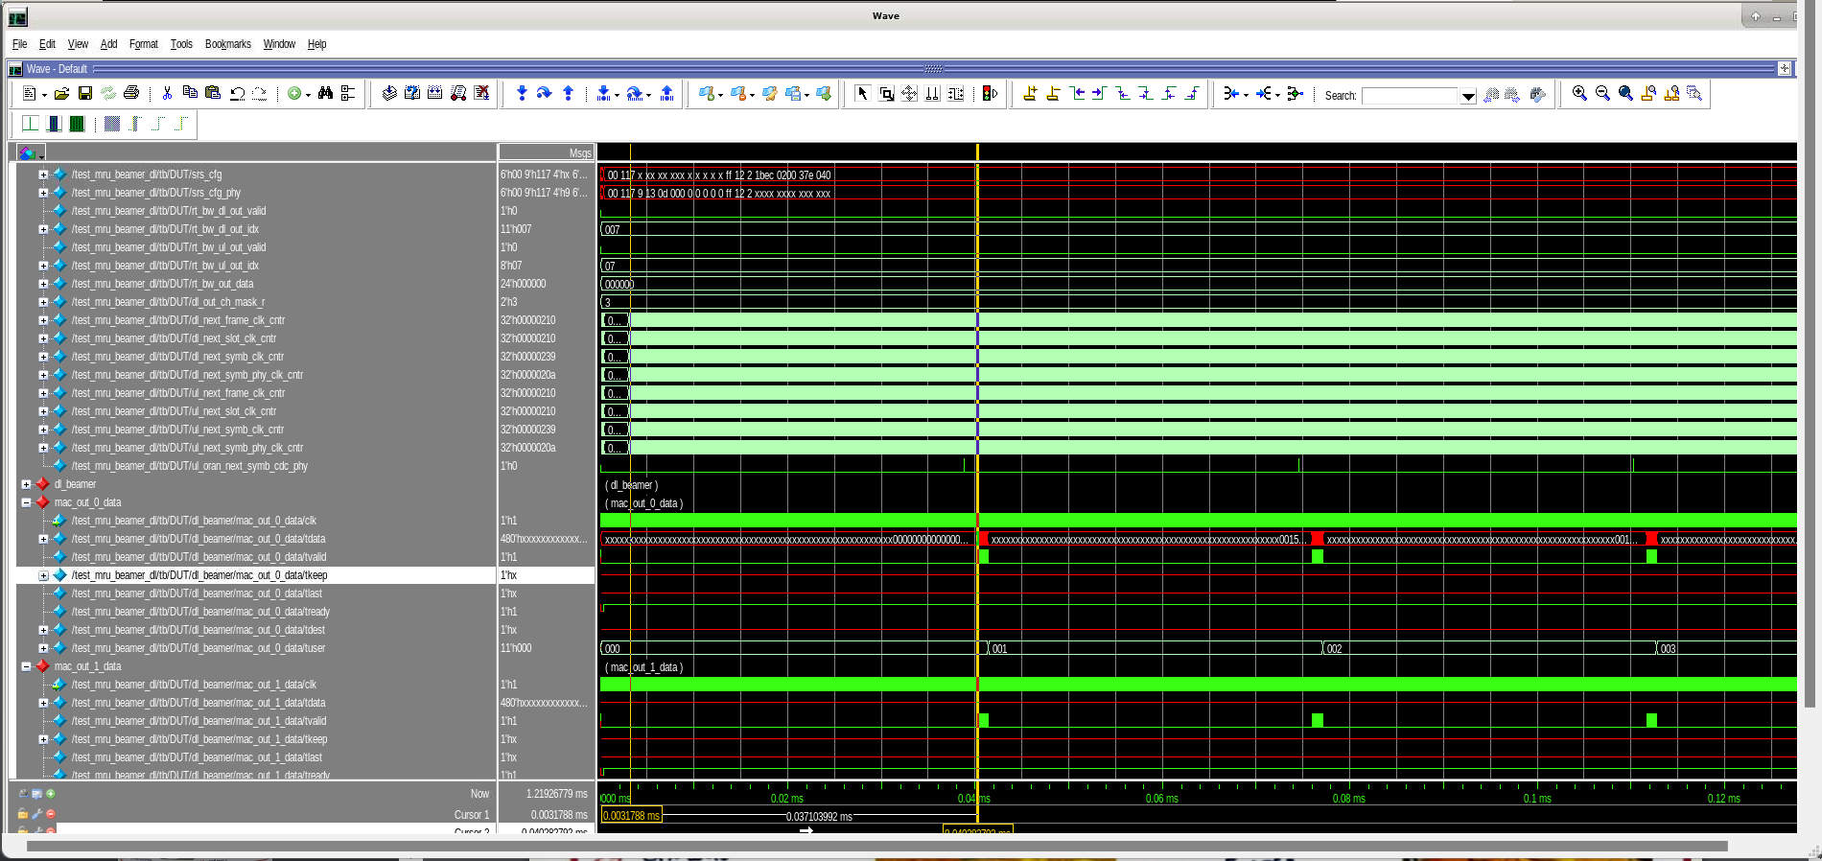

**9. Beamer IP I/O Interface**

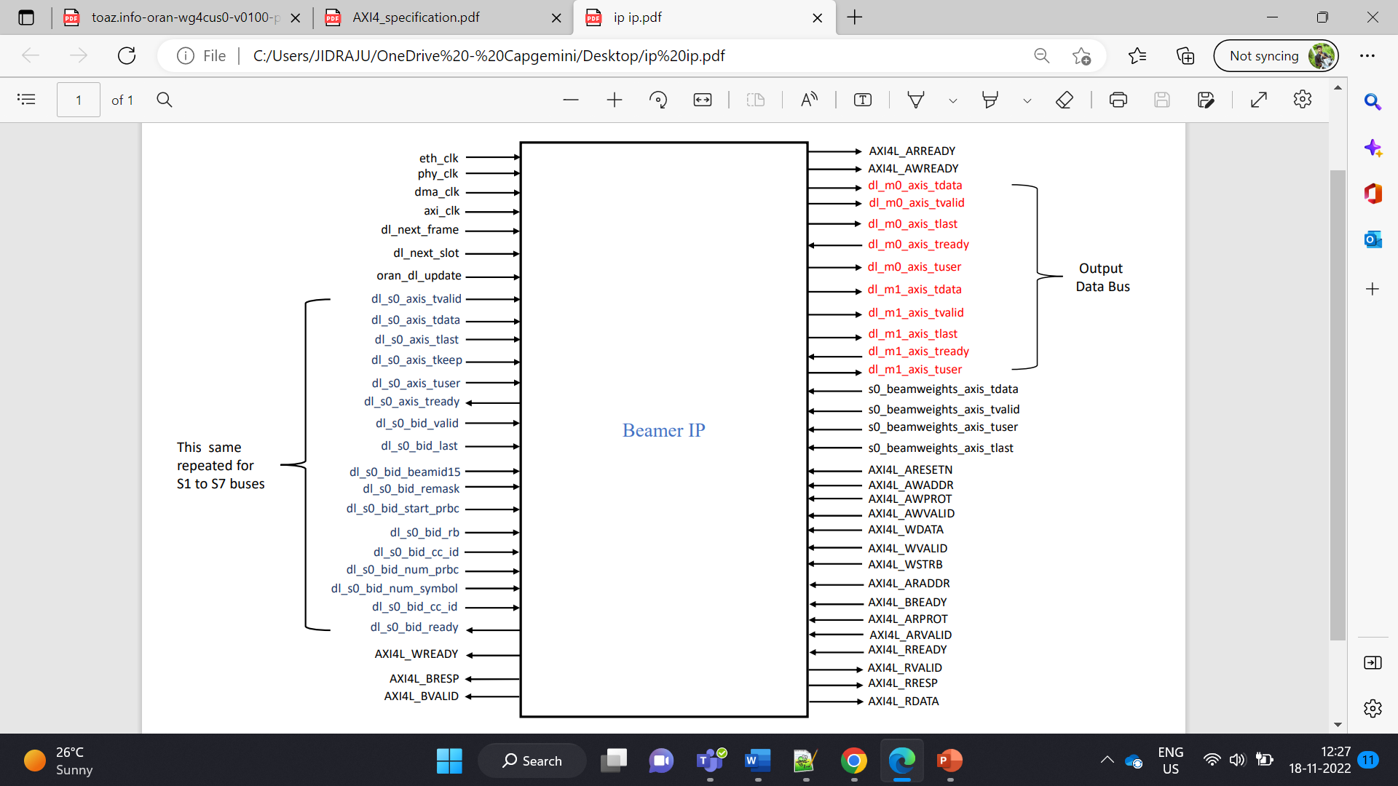

**Input & Output configuration:**

1. There are 4 clock signals giving to Beamer IP – eth clk, dma clk, phy clk, axi clk

2. dl_next_frame & dl_next_slot indicates frame & slot numbers

3. oran_dl_update represents symbol status

4. For 8 antenna ports, 8 separate data buses & bid buses using.

I/O signals from ethernet/oran to beamer IP: dl_s0_axis indicates first data bus (s0) and it contain further sub signals, indicates data bus status (tdata, tvalid, tlast, tuser, tkeep, tready).

Same as like this for remaining data buses also exists

dl_s1_axis_tdata, dl_s2_axis_tdata, dl_s3_axis_tdata, dl_s4_axis_tdata, dl_s5_axis_tdata, dl_s6_axis_tdata, dl_s7_axis_tdata

dl_s0_axis_tdata

dl_s0_axis_tvalid

dl_s0_axis_tlast

dl_s0_axis_tuser

dl_s0_axis_tkeep

dl_s0_axis_tready

**BID Bus**: dl_s0_bid indicates first bid bus (s0) which carries C plane information and it contain further sub signals, indicates bid bus status (last, ready, beamid15, remask, rb, start_prbc, num_prbc, num_symbol, cc_id.

Same as like this for remaining bid buses also exists

dl_s1_bid_valid, dl_s2_bid_valid, dl_s3_bid_valid, dl_s4_bid_valid, dl_s5_bid_valid, dl_s6_bid_valid, dl_s7_bid_valid

dl_s0_bid_valid

dl_s0_bid_last

dl_s0_bid_ready

dl_s0_bid_beamid15

dl_s0_bid_remask

dl_s0_bid_rb

dl_s0_bid_start_prbc

dl_s0_bid_num_prbc

dl_s0_bid_num_symbol

dl_s0_bid_cc_id

I/O signals from beamer ip to Aurora:

The main block in dl beamer is mac core. When MAC operation is completed, resulting signals are carried by two output data buses (mac_out0 & mac_out1).

dl_m0_axis_tdata,

dl_m0_axis_tvalid,

dl_m0_axis_tlast,

dl_m0_axis_tuser,

dl_m0_axis_tready,

dl_m1_axis_tdata

dl_m1_axis tvalid

dl_m1_axis_tlast

dl_m1_axis_tuser

dl_m1_axis_tready

For 100Mhz bandwidth, 273 PRB’s are used in this design, Each PRB consists of 12 RE’s. Each RE (Resource Element) carries one sub carrier. When data is given to beamer, it processes based on symbol approach. Per one symbol, data goes to first sub carrier (RE) of first PRB & which covers all antenna streams & performing the operation, converted as 240-bit packet, which furthers gives to next block. Data packet size is determined by antenna ports & input data width.

**Data bus inputs:**

**dl_s0_axis_tdata(*):** This bus signal carries actual input data information to be transmit. It is 64-bit length signal bus. Tb drives the dut by generating data with a constant counter method. A integer ‘z’ variable is taken to perform counter for data gen.

This z is assigned with z = stream_i*2+15+2*j; //stream_i = 8, j = tb_len_clk.

Where tb_len_clk = tb_len/2 + tb_len%2 + 1; //tb_len depends on rb_num

tb_num refers frame number & tb_len refers eth frame length.

Ex: when 1st frame is running, tb_num = 1, where tb_len is frame length (10ms dur i.e.. 20 slots), tb_num = rb_num * 12; // tb_num = 273 * 12

The resulted z value is loaded temporary data registers, which are further assigned to data_in of dut which drives the dl_s0_axis_tdata.

**dl_s0_axis_tvalid(*):** When data is present in data bus, this valid signal becomes high

**dl_s0_axis_tlast(*):** TLAST indicates the last transfer in a block (block end marker). Word counter data is given to this signal. IP-specific TLAST used to mark an IP specific location in the data transfers. It is a 8 bit length.

**dl_s0_axis_tkeep(ff):** For Packetized Data, TKEEP might be necessary to signal packet remainders. This usage of TKEEP essentially encodes the remainder bytes after the end of a packet which is an artifact of upsizing a packet beyond the atomic size of the data. It is an optional AXI Stream signal & there is only a limited use of null bytes to encode the remainders bytes at the end of packetized streams.

**dl_s0_axis_tuser(*):** The AXI4-Stream interface protocol allows passing sideband signals using the TUSER bus. This signal carried PRB number data. It is 30-bit length bus. tuser starts with start_prbc value & continues upto rb_num for each symbol.

**dl_s0_axis_tready(*):** An AXI4-Stream master cannot use the status of S_AXIS_TREADY unless a transfer is started. TREADY can be asserted and deasserted whenever the AXI4-Stream slave requires assertion and deassertion.

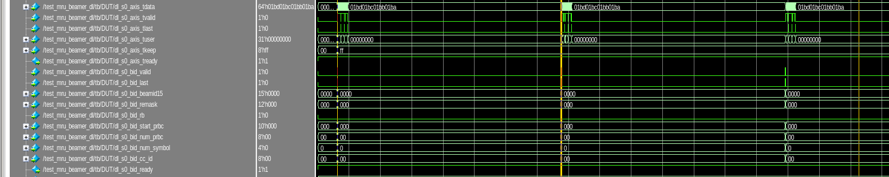

**Bid bus inputs:**

**dl_s0_bid_valid(*):** When data is present in bid bus, this valid signal becomes high

**dl_s0_bid_last(*):** TLAST indicates the last transfer in a block (block end marker).

**dl_s0_bid_rb(*):** Resource block indicator. This parameter is used to indicate if every RB is used or every other RB is used. The starting RB is defined by startPrbc and total number of used RBs is defined by numPrbc.

**dl_s0_bid_start_prbc(*):** This parameter is the starting PRB of a data section described in the C-Plane message. Values of startPrbc and numPrbc must ensure that data sections must never overlap: a single PRB may only exist within one data section for a given value of eAxC. For one C-Plane message, there may be multiple U-Plane messages associated with it and requiring defining from which PRB the control commands are applicable. It is 10-bit length.

**dl_s0_bid_num_prbc(*):** Number of contiguous PRBs per data section. This parameter defines the PRBs within the data section being described. Values of startPrbc and numPrbc must ensure that data sections must never overlap: a single PRB may only exist within one data section for a given value of eAxC. It is 8-bit length.

**dl_s0_bid_num_symbol(*):** This parameter defines number of symbols to which the section control is applicable. At minimum, the section control shall be applicable to at least one symbol. However, possible optimizations could allow for several (upto 14) symbols, if e.g., all 14 symbols use the same beam ID. It is 4-bit length

**dl_s0_bid_beamid15(*):** This parameter defines the beam pattern to be applied to the U-Plane data, beamId = 0 means no beamforming operation will be performed. BeamID may indicate the “state” of an antenna array not explicitly comprising separate radiating elements which is also possible within the O-RAN specification. The specific mapping of beamId to e.g. weight table, beam attributes, directionality, beam adjacency or any other beam designator is specific to the O-RU design and must be conveyed via M-Plane from the O-RU to O-DU upon startup. It is 15 bit length bus. This beamid value is loaded by bid_table_ss_tb value. bid_table_ss_tb is loaded with corresponding TEST_BEAM_BID_SS value w.r.t current stream.

Ex: if stream_i is 0, bid_table_ss_tb[symb_i][stream_i][tb_i] = TEST_BEAM_BID_SS_0

**dl_s0_bid_cc_id(*):** It distinguishes Carrier Components supported by the O-RU. It is 8 bit length. This has random values between 1 to 256.

**dl_s0_bid_remask(*):** Resource element mask. This parameter defines the Resource Element (RE) mask within an PRB. Each bit setting in the reMask indicates if the section control is applicable to the RE sent in U-Plane messages (0=not applicable; 1=applicable).

**dl_s0_bid_ready(*):** TREADY can be asserted and deasserted whenever the ORAN BID interface slave requires assertion and deassertion.

**Output Data bus:**

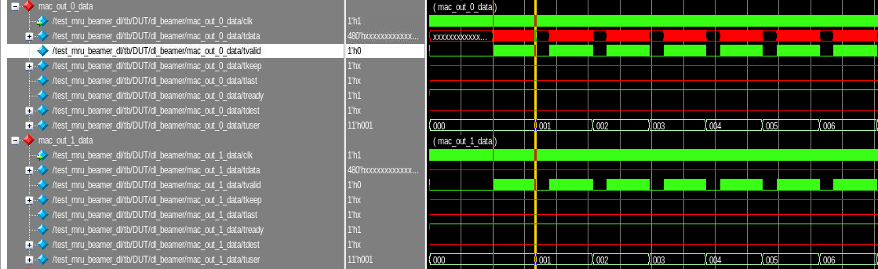

**dl_m0_axis_tdata(*):** This bus signal carries actual output data information to be transmit. It is 240-bit length signal bus. Each symbol will cover all sub carriers in PRB’s. When the symbol data enters into sub carrier, it goes through all 8 antenna streams. Each antenna port stream is 30-bit wide. So, the output bus should have 8 x 30 = 240 bit size.

**dl_m0_axis_tvalid(*):** When data is present in data bus, this valid signal becomes high

**dl_m0_axis_tlast(X):** TLAST indicates the last transfer in a block (block end marker). Word counter data is given to this signal. IP-specific TLAST used to mark an IP specific location in the data transfers.

**dl_m0_axis_tuser(*):** The AXI4-Stream interface protocol allows passing sideband signals using the TUSER bus. This signal carried PRB number data. It is 12-bit length.

**dl_m0_axis_tready(*):** An AXI4-Stream master cannot use the status of S_AXIS_TREADY unless a transfer is started. TREADY can be asserted and deasserted whenever the AXI4-Stream slave requires assertion and deassertion.

**Signals from Reg Map:**

**AXI4L_ARESETN:** The AXI protocol uses a single active LOW reset signal, ARESETn. The reset signal can be asserted asynchronously, but deassertion must be synchronous with a rising edge of ACLK.

**AXI4L_AWADDR:** Used to write address. The write address gives the address of the first transfer in a write burst transaction.

**AXI4L_AWPROT:** AXI provides access permissions signals that can be used to protect against illegal transactions. Used for Protection type. This signal indicates the privilege and security level of the transaction, and whether the transaction is a data access or an instruction access.

**AXI4L_AWVALID:** Write address valid. This signal indicates that the channel is signaling valid write address and control information. The master can assert the AWVALID signal only when it drives valid address and control information. When asserted, AWVALID must remain asserted until the rising clock edge after the slave asserts AWREADY.

**AXI4L_AWREADY:** Write address ready. This signal indicates that the slave is ready to accept an address and associated control signals. The default state of AWREADY can be either HIGH or LOW. This specification recommends a default state of HIGH. When AWREADY is HIGH the slave must be able to accept any valid address that is presented to it.

**AXI4L_WDATA:** Used to Write data.

**AXI4L_WSTRB:** Write strobes. This signal indicates which byte lanes hold valid data. There is one write strobe bit for each eight bits of the write data bus. The WSTRB[n:0] signals when HIGH, specify the byte lanes of the data bus that contain valid information.

**AXI4L_WVALID:** Write valid. This signal indicates that valid write data and strobes are available. During a write burst, the master can assert the WVALID signal only when it drives valid write data. When asserted, WVALID must remain asserted until the rising clock edge after the slave asserts WREADY.

**AXI4L_WREADY:** Write ready. This signal indicates that the slave can accept the write data. The default state of WREADY can be HIGH, but only if the slave can always accept write data in a single cycle.

**AXI4L_BRESP:** Write response. This signal indicates the status of the write transaction.

**AXI4L_BVALID:** Write response valid. This signal indicates that the channel is signaling a valid write response. The slave can assert the BVALID signal only when it drives a valid write response. When asserted, BVALID must remain asserted until the rising clock edge after the master asserts BREADY.

**AXI4L_BREADY:** Response ready. This signal indicates that the master can accept a write response.

**AXI4L_ARADDR:** Read address. The read address gives the address of the first transfer in a read burst transaction.

**AXI4L_ARPROT:** ARPROT defines the access permissions for read accesses. Protection type. This signal indicates the privilege and security level of the transaction, and whether the transaction is a data access or an instruction access.

**AXI4L_ARVALID:** Read address valid. This signal indicates that the channel is signaling valid read address and control information.

**AXI4L_ARREADY:** Read address ready. This signal indicates that the slave is ready to accept an address and associated control signals.

**AXI4L_RDATA:** Acts as slave for Read data.

**AXI4L_RRESP:** Read response. This signal indicates the status of the read transfer.

**AXI4L_RVALID:** Read valid. This signal indicates that the channel is signaling the required read data

**AXI4L_RREADY:** Read ready. This signal indicates that the master can accept the read data and response information.

Some local parameters are helped to define the bus widths:

ORAN_DATA_WIDTH = 64

ORAN_USER_WIDTH = 31

ORAN_KEEP_WIDTH = 8

ORAN_REQ_WIDTH = 33

BW_DATA_WIDTH = 64

BW_USER_WIDTH = 4

BW_COEFF_WIDTH = 12

AU_AXIS_DATA_WIDTH = 240

AU_AXIS_USER_WIDTH = 12

AXI4L_DATA_WIDTH = 32

AXI4L_ADDR_WIDTH = 32

DL_MAC_TRUE_BEAMER = 1

DL_MAC_BC_SIZE = 128

DL_MAC_AP_NUM = 8

DL_MAC_SS_COUPLE_NUM = 4

SMPL_AXI_ADDR_W = 12

SMPL_AXI_DATA_W = 32

1. **Beam weights Configuration**

There are two ways by which we can transfer the beam weights to the DL beamer subsystem.

1. Register map interface with register number 0x20 and 0x21.
2. s0_beamweights_axis Bus.

**Register map interface** : To select this interface we need to disable(0) 23rd bit of 0x3 register. This interface is written in register map file which uses 0x20 and 0x21 registers to write all beam weights into DL weights RAM. Its details are shared in the Register parameters excel sheet. We can drive this interface via BSP software code.

Reference code for this interface is given below :

for(int bid_cntr = 0; bid_cntr < TEST_BID_NUM; bid_cntr++) begin

for ( int ap_cntr = 0; ap_cntr < 32; ap_cntr++) begin

weight = beam_cache_weight_matr[bid_cntr][ap_cntr];

bc_ram_addr_cntr = bid_cntr * 32 + ap_cntr;

bc_curr_val[0 +: 24] = weight;

reg_map_AXI4L_write_reg(axi_clk, 33, bc_curr_val);

reg_map_AXI4L_write_reg(axi_clk, 32, {16'd0, {13'(bc_ram_addr_cntr)}, 2'd1, 1'b1});

end

end

**S0_beamweights_axis Bus** : To select this interface we need to enable(1) 23rd bit of 0x3 register.

If DL_BEAMWEIGHTS_EN(23rd bit) is high (1) then our beam weights will be written via s0_beamweights_axis interface. It includes four signals as defined below.

s0_beamweights_axis_tdata : 64 bit, Our weight coefficients are written via this signal.

s0_beamweights_axis_tvalid : 1 bit, Should be high for valid write.

s0_beamweights_axis_tlast : 1 bit, This is high when last packet is transmitted.

s0_beamweights_axis_tuser : 4 bit , For first ,second and last packet tuser0,tuser1 and tuser2 is written high respectively. For other case its value will be 0.

As per the reference code some information is extracted to drive beam weights. slot_i, symb_i, beam_cache_weight_matr[bid_i][ap_i] data is assigned to send dl_beamweights. In this interface, beam_id_num_list is default generated based on beam cache size. two_byte_compr_en is 0, so else loop starts execution.

If word_i = 0, beamweights_tdata 64 bit bus starts with initial values of start prbc, num symbol, SubFrameId, SlotId, StartSymbolId, StreamType, numprbc, cc_id. If word_i = 1, beamweights_tdata is loaded with beam_id_val & beam_cache_weight_matr data from tb. If word_i starts incrementing its value, half of the beamweights_tdata filled from tb beam_cache_weight_matr.The beamweights_tdata is connected to s0_beamweights_axis_tdata of DUT (beamer ip).

If TEST_DL_BEAMWEIGHTS_EN is 1, then the beam weights data is connected to real time beam weight data bus signal through s0_beamweights_bus, otherwise it won't be connected if it is disabled. In the disabled case it will be connected to register map bus data.